**DEPARTMENT OF COMPUTER SCIENCE**

**RAJAGIRI COLLEGE OF SOCIAL SCIENCES**

**(Autonomous)**

**KALAMASSERY - KOCHI - 683104**



MASTER OF COMPUTER APPLICATIONS

**DS LAB RECORD**

**NAME : ___ALBIN JOSEPH_________**

**SEMESTER : ___1ST SEMESTER__________**

**REGISTER NO. : ______________________________**



**DEPARTMENT OF COMPUTER SCIENCE**

**RAJAGIRI COLLEGE OF SOCIAL SCIENCES**

**(Autonomous)**

**KALAMASSERY - KOCHI – 683104**

**MASTER OF COMPUTER APPLICATIONS**

CERTIFICATE

**NAME : ___ALBIN JOSEPH_______**

**SEMESTER : ___1ST SEMESTER________**

**REGISTER NO. : __________________________**

*Certified that this is a bonafide record of work done by the student in the Software Laboratory of Rajagiri Department of Computer Science, Kalamassery.*

Faculty in Charge Dean, Computer Science

Internal Examiner External Examiner

Place : Kalamassery

Date :

**Table of Contents Page No**

|  |  |
| --- | --- |
| 1. Write programs to demonstrate the usage of storage classes in C | 1 |
| 2. Use a menu driven program to insert, search, delete and sort elements in an array using functions (use global variables) | 3 |
| 3. Use a menu driven program to insert, search, delete and sort elements in an array using functions (use only local variables) | 5 |
| 4. Search for all the occurrence of an element in an integer array (positions) | 7 |
| 5. Sort the array elements in ascending order (minimum three functions - read, disp and sort) | 11 |
| 6. Two Dimensional Matrix - using functions Sept 16, 2022   * 1. Addition   2. Subtraction   3. Multiplication   4. Transpose   [Need to discuss before implementing]   5. Determinant | 13 |
| 7. Display the array elements in the same order using a recursive function | 17 |
| 8. Display array elements in the reverse order using a recursive function | 18 |
| 9. Implement stack operations using array | 19 |
| 10. Reverse a string using Stack | 20 |
| 11. Convert an expression from infix to postfix using stack | 21 |
| 12. Evaluate an expression using stack | 23 |
| 13. Define a structure for date having dd/mm/yyyy. Provide functions for reading, displaying and comparing two dates are equal or not | 26 |
| 14. Define Define a structure for employees having eno,ename, esal and dno. Read  n employees information and provide function for the following  a. Searching an employee by no   1. Sorting the employee by    * 1. Name      2. Salary 2. Deleting an employee | 30 |
| 15. Read a polynomial and display - use array | 33 |
| 16. Add two polynomials - using array itself | 40 |

|  |
| --- |
| **Program 1** |
| **Write programs to demonstrate the usage of storage classes in C.** |

**Source Code:**

#include <stdio.h>

int a = 5, b; // Global variables

void print() {

    printf("The value of global variable a is %d (assigned)\n", a);

    printf("The value of global variable b is %d (default value is undefined)\n", b);

}

void display() {

    static int i; // Static variable

    printf("Value of static variable i is %d (default initialized value)\n", i);

    static int k = 1;

    printf("Assigned value of static variable k = %d\n", k);

    k++;

}

void reg() {

    int h = 3; // Local variable

    printf("The value of h = %d (local variable)\n", h);

}

int main() {

    int c; // Local variable

    printf("The value of local variable c is %d (garbage value)\n", c);

    print();

    display();

    reg();

    return 0;

}

**Output:**

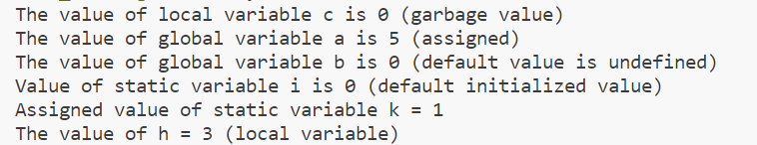

|  |
| --- |
| **Program 2** |
| **Use a menu-driven program to insert, search, delete and sort elements in an array using functions (use global variables)** |

**Source Code:**

#include <stdio.h>

int ar[10];

int n; // Global variable to track the number of elements in the array

int x; // Global variable to store the search element

void insert(int n) {

    int i;

    for (i = 0; i < n; i++) {

        scanf("%d", &ar[i]);

    }

    printf("\nElements are inserted\n");

}

void display() {

    int i;

    if (n > 0) {

        printf("Array elements are: ");

        for (i = 0; i < n; i++) {

            printf("%d", ar[i]);

            if (i < n - 1)

                printf(", ");

        }

        printf("\n");

    } else {

        printf("Array is empty\n");

    }

}

void delete() {

    if (n == 0) {

        printf("Array is empty\n");

    } else {

        printf("Last element of the array is deleted\n");

        n--;

    }

}

void sort() {

    int i, j;

    for (i = 0; i < n - 1; i++) {

        for (j = 0; j < n - i - 1; j++) {

            if (ar[j] > ar[j + 1]) {

                int temp = ar[j];

                ar[j] = ar[j + 1];

                ar[j + 1] = temp;

            }

        }

    }

    printf("Array sorted successfully.\n");

}

void search() {

    int i, flag = 0;

    for (i = 0; i < n; i++) {

        if (ar[i] == x) {

            flag = 1;

            printf("Element %d found at index %d.\n", x, i);

            break;

        }

    }

    if (flag == 0) {

        printf("Element %d not found in the array.\n", x);

    }

}

int menu() {

    int ch;

    printf("INSERT-1\nDELETE-2\nDISPLAY-3\nSORT-4\nSEARCH-5\nEXIT-6\nENTER YOUR CHOICE: ");

    scanf("%d", &ch);

    return ch;

}

void process() {

    int ch;

    for (ch = menu(); ch != 6; ch = menu()) {

        switch (ch) {

            case 1:

                printf("Enter the value of n: ");

                scanf("%d", &n);

                if (n <= 0) {

                    printf("Invalid value of n\n");

                    break;

                }

                printf("Enter the elements: ");

                insert(n);

                break;

            case 2:

                delete();

                break;

            case 3:

                display();

                break;

            case 4:

                sort();

                break;

            case 5:

                printf("Enter element to search: ");

                scanf("%d", &x);

                search();

                break;

            default:

                printf("Wrong choice\n");

                break;

        }

    }

}

int main() {

    process();

    return 0;

}

**Output:**

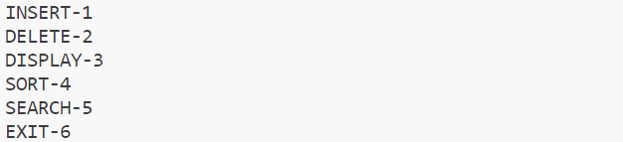

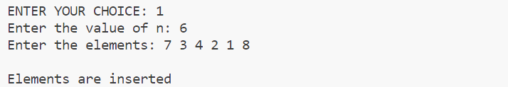











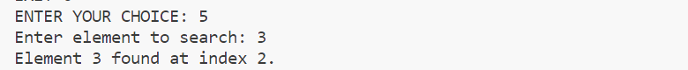

|  |
| --- |
| **Program 3** |
| **Use a menu driven program to insert, search, delete and sort elements in an array using functions (use only local variables).** |

**Source Code:**

#include<stdio.h>

void insert(int ar[], int n)

{

    int i;

    for(i=0;i<n;i++)

    {

        scanf("%d",&ar[i]);

    }

}

void display(int ar[], int n)

{

    int i;

    if(n>0){

        printf("Array elements are: ");

        for(i=0;i<n;i++)

        {

            printf("%d",ar[i]);

            if(i<n-1) printf(", ");

        }

        printf("\n");

    }

    else

    {

        printf("Array is empty\n");

    }

}

int delete(int ar[], int n)

{

    if(n==-1){

        printf("array is empty");

    }

    else{

        printf("last element of array is deleted");

        n=n-1;

    }

    return n;

}

void sort(int ar[], int n)

{

    int i, j;

    for (i = 0; i < n - 1; i++) {

        for (j = 0; j < n - i - 1; j++) {

            if (ar[j] > ar[j + 1]) {

                int temp = ar[j];

                ar[j] = ar[j + 1];

                ar[j + 1] = temp;

            }

        }

    }

    printf("Array sorted successfully.\n");

    return;

}

void search(int ar[], int n, int x)

{

    int i, flag = 0;

    for (i = 0; i < n; i++) {

        if (ar[i] == x) {

            flag = 1;

            printf("Element %d found at index %d.\n", x, i);

            break;

        }

    }

    if (flag == 0) {

        printf("Element %d not found in the array.\n", x);

    }

    return;

}

int menu()

{

    int ch;

    printf("\nINSERT-1\nDELETE-2\nDISPLAY-3\nSORT-4\nSEARCH-5\nEXIT-6\nENTER YOUR CHOICE: ");

    scanf("%d",&ch);

    return ch;

}

void process()

{

    int ch;

    int x;

    int ar[10];

    int n = -1;

    for(ch=menu();ch!=6;ch=menu())

    {

        switch(ch)

        {

            case 1:

                printf("Enter the value of n: ");

                scanf("%d",&n);

                if(n<=0){

                    printf("Invalid value of n\n");

                    break;

                }

                printf("Enter the elements: ");

                insert(ar,n);

                break;

            case 2:

               n = delete(ar,n);

               break;

            case 3:

                display(ar,n);

                break;

            case 4:

               sort(ar,n);

               break;

            case 5:

                printf("enter element to search");

                scanf("%d",&x);

                search(ar,n,x);

                break;

            default:

               printf("Wrong choice\n");

               break;

        }

    }

}

int main()

{

   process();

   return 0;

}

**Output:**

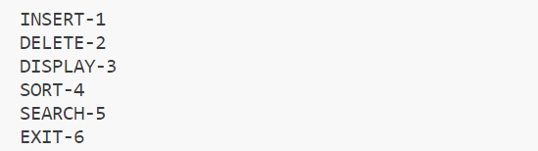

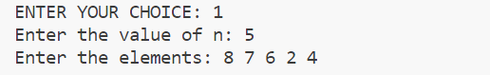







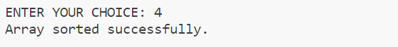

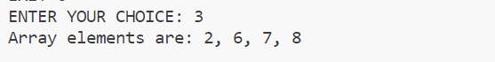

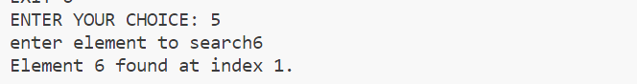

|  |
| --- |
| **Program 4** |
| **Search for all the occurrences of an element in an integer array (positions)** |

**Source Code:**

#include<stdio.h>

int main()

{

    int a[10],i,n,num,p[10];

    int count=0;

    printf("Enter the size of the array: ");

    scanf("%d",&n);

    printf("Enter array elements: ");

    for(i=0;i<n;i++)

    {

        scanf("%d",&a[i]);

    }

    printf("Enter the array elment to find: ");

    scanf("%d",&num);

    for(i=0;i<n;i++)

    {

        if(a[i]==num)

        {

            p[count]=i;

            count++;

        }

    }

    printf("Occurrence of %d is: %d Times\n", num, count);

    printf("Positions of %d are index: ", num);

    for(i = 0; i < count; i++)

    {

        printf("%d ", p[i]);

    }

    return 0;

}

**Output:**

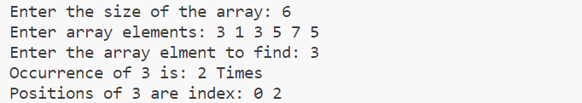

|  |
| --- |
| **Program 5** |
| **Sort the array elements in ascending order (minimum three functions - read, disp and sort).** |

**Source Code:**

#include<stdio.h>

#define MAX_SIZE 100

int arr[MAX_SIZE],n,i;

void read()

{

    printf(" Enter array elements:");

    for(i=0;i<n;i++)

    {

    scanf("%d",&arr[i]);

    }

}

void disp()

{

    printf(" Array elements are:");

    for(i=0;i<n;i++)

    {

    printf(" %d",arr[i]);

    }

}

void sort()

{

    int j,t;

    for(i=0;i<n;i++){

        for(j=0;j<(n-1)-i;j++){

            if(arr[j]>arr[j+1]){

                t=arr[j];

                arr[j]=arr[j+1];

                arr[j+1]=t;

            }

        }

    }

    printf("Array sorted");

}

void del()

{

    int i;

    if(n == -1){

        printf("ARRAY IS EMPTY");

    }

    else{

        printf("Enter the index of the element to delete: ");

        int pos;

        scanf("%d", &pos);

        if(pos < 0 || pos >= n){

            printf("Invalid index");

        }

        else{

            printf("Deleted element is %d ", arr[pos]);

            for(i = pos; i < n - 1; i++){

                arr[i] = arr[i + 1];

            }

            n--;

        }

    }

}

int menu()

{

    int ch;

    printf("\n INSERT-1\n DISPLAY-2\n SORT-3\n DELETE-4\n EXIT-5\n Enter your choice: ");

    scanf("%d",&ch);

    return ch;

}

void process()

{

    int ch;

    for(ch=menu();ch!=5;ch=menu())

    {

        switch(ch)

        {

            case 1:

                printf("enter the number of elements to enter: ");

                scanf("%d",&n);

                read();

                break;

            case 2:

                disp();

                break;

            case 3:

                sort();

                break;

            case 4:

                del();

                break;

            default:

                printf("wrong choice");

                break;

        }

    }

}

int main()

{

    process();

}

**Output:**

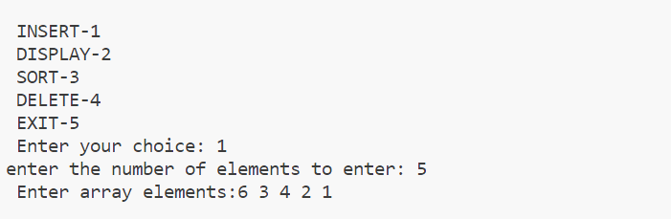

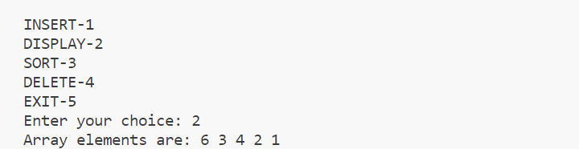

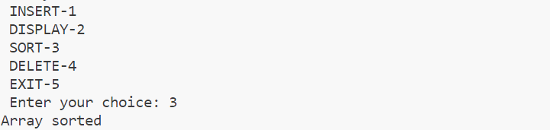

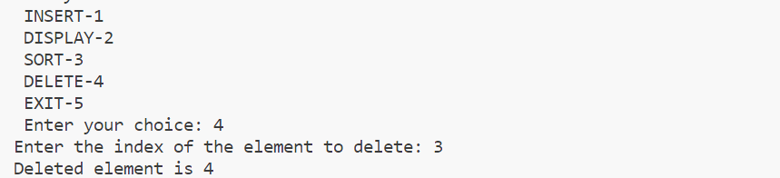

|  |
| --- |
| **Program 6** |
| **Two-dimensional matrix: using functions**   * 1. **Addition**   2. **Subtraction**   3. **Multiplication**   4. **Transpose**   5. **Determinant** |

**Source Code:**

#include <stdio.h>

#include <process.h>

void add(int a[10][10], int b[10][10], int m, int n)

{

  int i, j, sum[10][10];

  for (i = 0; i < m; i++)

  {

    for (j = 0; j < n; j++)

      sum[i][j] = a[i][j] + b[i][j];

  }

  printf("\n Addition :");

  for (i = 0; i < m; i++)

  {

    printf("\n");

    for (j = 0; j < n; j++)

      printf("%d\t", sum[i][j]);

  }

}

void sub(int a[10][10], int b[10][10], int m, int n)

{

  int i, j, sub[10][10];

  for (i = 0; i < m; i++)

  {

    for (j = 0; j < n; j++)

      sub[i][j] = a[i][j] - b[i][j];

  }

  printf("\n Subtraction :");

  for (i = 0; i < m; i++)

  {

    printf("\n");

    for (j = 0; j < n; j++)

      printf("%d\t", sub[i][j]);

  }

}

void det(int a[10][10], int m, int n)

{

  int det, i, j;

  if (m == 2)

  {

    det = (a[0][0] * a[1][1]) - (a[0][1] * a[1][0]);

    printf("%d", det);

  }

  else if (m == 3)

  {

    det = a[0][0] * ((a[1][1] * a[2][2]) - (a[2][1] * a[1][2])) - a[0][1] * (a[1][0] * a[2][2] - a[2][0] * a[1][2]) + a[0][2] * (a[1][0] * a[2][1] - a[2][0] * a[1][1]);

    printf("%d", det);

  }

}

void trans(int a[10][10], int m, int n)

{

  int trans[10][10], i, j;

  for (i = 0; i < m; i++)

  {

    for (j = 0; j < n; j++)

      trans[i][j] = a[j][i];

  }

  for (i = 0; i < m; i++)

  {

    printf("\n");

    for (j = 0; j < n; j++)

      printf("%d\t", trans[i][j]);

  }

}

void mul(int a[10][10], int b[10][10], int m, int n, int p, int q)

{

  int k, prod[10][10], i, j;

  for (i = 0; i < m; i++)

  {

    for (j = 0; j < q; j++)

      prod[i][j] = 0;

  }

  for (i = 0; i < m; i++)

  {

    for (j = 0; j < q; j++)

    {

      for (k = 0; k < n; k++)

        prod[i][j] += a[i][k] * b[k][j];

    }

  }

  printf("\n Multiplication :");

  for (i = 0; i < m; i++)

  {

    printf("\n");

    for (j = 0; j < n; j++)

      printf("%d\t", prod[i][j]);

  }

}

void main()

{

  int a[10][10], b[10][10], m, i, j, n, p, q, ch;

  printf("\n\t\tMATRIX OPERATIONS");

  printf("\n\t\t-----------------");

  printf("\n Enter row and column of matrix A:");

  scanf("%d%d", &m, &n);

  printf("\n Enter row and column of matrix B:");

  scanf("%d%d", &p, &q);

  printf("\n Enter elements of matrix A:");

  for (i = 0; i < m; i++)

  {

    for (j = 0; j < n; j++)

      scanf("%d", &a[i][j]);

  }

  printf("\n Enter elements of matrix B:");

  for (i = 0; i < p; i++)

  {

    for (j = 0; j < q; j++)

      scanf("%d", &b[i][j]);

  }

  printf("\n----------");

  printf("\nMATRIX A :");

  printf("\n----------");

  for (i = 0; i < m; i++)

  {

    printf("\n");

    for (j = 0; j < n; j++)

      printf("%d\t", a[i][j]);

  }

  printf("\n----------");

  printf("\n MATRIX B :");

  printf("\n----------");

  for (i = 0; i < p; i++)

  {

    printf("\n");

    for (j = 0; j < q; j++)

      printf("%d\t", b[i][j]);

  }

  do

  {

    printf("\n=====\nMenu\n=====\n1.Addition\n2.Subtraction\n3.Multiplication\n4.Determinant\n5.Transpose\n6.Exit\nEnter your choice:");

    scanf("%d", &ch);

    switch (ch)

    {

    case 1:

      if (m == p && n == q)

        add(a, b, m, n);

      else

        printf("Not possible...");

      break;

    case 2:

      if (m == p && n == q)

        sub(a, b, m, n);

      else

        printf("Not possible.....");

      break;

    case 3:

      mul(a, b, m, n, p, q);

      break;

    case 4:

      if (m == n && p == q)

      {

        printf("\n Determinant of matrix A=");

        det(a, m, n);

        printf("\n Determinant of matrix B=");

        det(b, p, q);

      }

      else

        printf("Not possible...");

      break;

    case 5:

      printf("\n Transpose of matrix A:");

      trans(a, m, n);

      printf("\n Transpose of matrix B :");

      trans(b, p, q);

      break;

    case 6:

      exit(1);

    }

  } while (1);

}

**Output:**

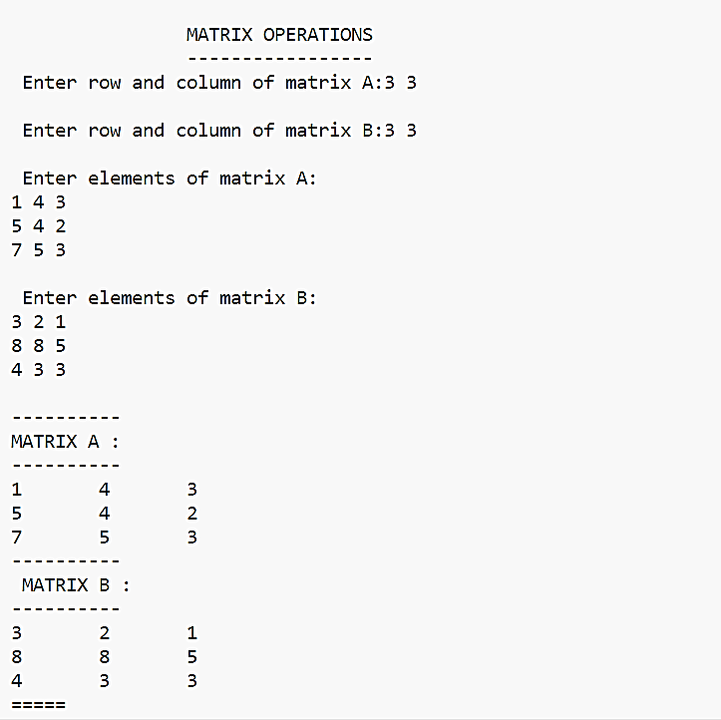

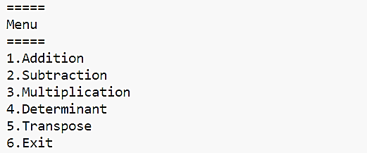

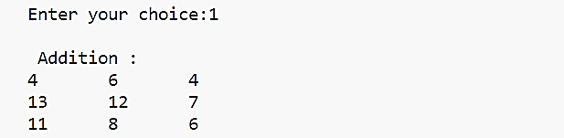

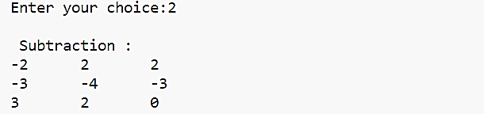

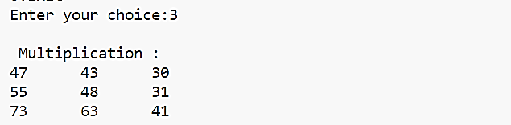

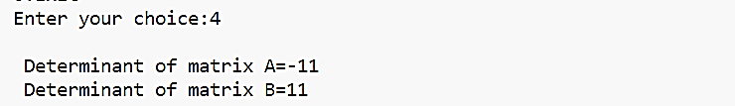

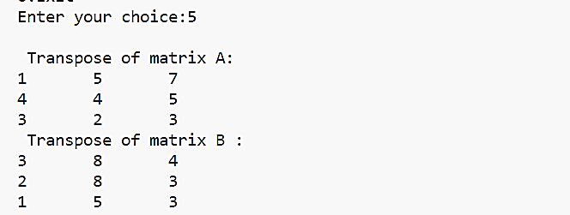

|  |
| --- |
| **Program 7** |
| **Display the array elements in the same order using a recursive function.** |

**Source Code:**

#include<stdio.h>

int dispArr(int a[10],int size,int i){

if(i==size){

return 0;

}

else{

printf("%d ",a[i]);

i++;

return dispArr(a,size,i);

}

}

void main(){

int size,i,a[10];

printf("\nEnter the size:");

scanf("%d",&size);

for(i=0;i<size;i++){

printf("\nEnter element %d:",i+1);

scanf("%d",&a[i]);

}

printf("\nArray Elements Are:");

dispArr(a,size,0);

}

**Output:**

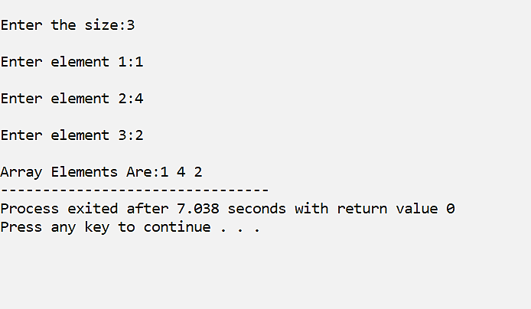

|  |
| --- |
| **Program 8** |
| **Display array elements in the reverse order using a recursive function.** |

**Source Code:**

#include<stdio.h>

int dispArrRev(int a[10],int size){

if(size==0){

return 0;

}

else{

size=size-1;

printf("%d ",a[size]);

return dispArrRev(a,size);

}

}

void main(){

int size,i,a[10];

printf("\nEnter the size:");

scanf("%d",&size);

for(i=0;i<size;i++){

printf("\nEnter element %d:",i+1);

scanf("%d",&a[i]);

}

printf("\nArray Elements Are:");

dispArrRev(a,size);

}

**Output:**

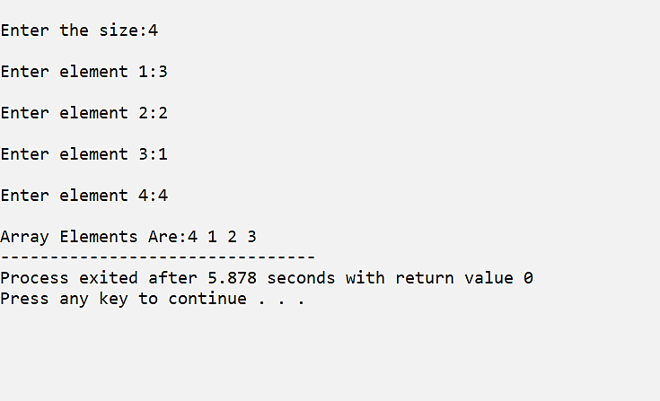

|  |
| --- |
| **Program 9** |
| **Implement stack operations using array.** |

**Source Code:**

#include <stdio.h>

#define MAX_SIZE 100

int top = -1;

int stack[MAX_SIZE];

void push(int element) {

    if (top == MAX_SIZE - 1) {

        printf("Stack overflow\n");

        return;

    }

    top++;

    stack[top] = element;

    printf("\n%d is pushed",element);

}

void pop() {

    if (top == -1) {

        printf("Stack underflow\n");

    }

    else{

            printf("\n%d is popped",stack[top]);

            top--;

    }

}

void peek()

{

    if(top==-1)

    {

        printf("stack underflow\n");

    }

    else

    {

        printf("\nElement at top is %d\n",stack[top]);

    }

}

int main() {

    push(1);

    push(2);

    push(3);

    peek();

    pop();

    pop();

    pop();

    pop();

    peek();

    return 0;

}

**Output:**

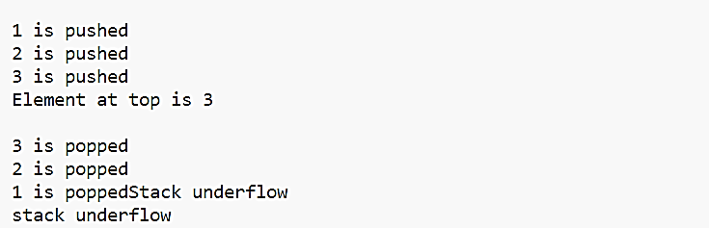

|  |
| --- |
| **Program 10** |
| **Reverse a string using Stack.** |

**Source Code:**

#include<stdio.h>

#include<string.h>

char stack[10],top =-1;

char a[10];

int i;

void pop()

{

    printf("Reversed string is");

    for(i=top;top>-1;top--)

    {

        printf(" %c",stack[top]);

    }

}

void push()

{

    for(i=0;i<strlen(a);i++)

    {

        top++;

        stack[top]=a[i];

    }

}

int main()

{

    printf("Enter the string:");

    gets(a);

    push(a);

    pop();

}

**Output:**

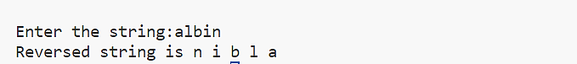

|  |
| --- |
| **Program 11** |
| **Convert an expression from infix to postfix using stack** |

**Source Code:**

#include <stdio.h>

#include <string.h>

#include <stdlib.h>

#define MAX 100

char stack[MAX];

char infix[MAX], postfix[MAX];

int top = -1;

void push(char);

char pop();

int isEmpty();

void inToPost();

int isOperator(char);

int precedence(char);

void print();

int main()

{

    printf("Enter the infix expression: ");

    gets(infix);

    inToPost();

    print();

    return 0;

}

void inToPost()

{

    int i, j = 0;

    char symbol, next;

    for (i = 0; i < strlen(infix); i++)

    {

        symbol = infix[i];

        if (symbol == '(')

        {

            push(symbol);

        }

        else if (symbol == ')')

        {

            while ((next = pop()) != '(')

                postfix[j++] = next;

        }

        else if (isOperator(symbol))

        {

            while (!isEmpty() && precedence(stack[top]) >= precedence(symbol))

                postfix[j++] = pop();

            push(symbol);

        }

        else

        {

            postfix[j++] = symbol;

        }

    }

    while (!isEmpty())

        postfix[j++] = pop();

    postfix[j] = '\0';

}

int isOperator(char c)

{

    return (c == '+' || c == '-' || c == '*' || c == '/' || c == '^');

}

int precedence(char symbol)

{

    switch (symbol)

    {

    case '^':

        return 3;

    case '/':

    case '*':

        return 2;

    case '+':

    case '-':

        return 1;

    default:

        return 0;

    }

}

void print()

{

    int i = 0;

    printf("The equivalent postfix expression is: ");

    while (postfix[i])

    {

        printf("%c", postfix[i++]);

    }

    printf("\n");

}

void push(char c)

{

    if (top == MAX - 1)

    {

        printf("Stack overflow\n");

        exit(1);

    }

    top++;

    stack[top] = c;

}

char pop()

{

    char c;

    if (top == -1)

    {

        printf("Stack underflow\n");

        exit(1);

    }

    c = stack[top];

    top = top - 1;

    return c;

}

int isEmpty()

{

    if (top == -1)

        return 1;

    else

        return 0;

}

**Output:**



|  |
| --- |
| **Program 12** |
| **Evaluate an expression using stack.** |

**Source Code:**

#include <stdio.h>

#include <string.h>

#include <stdlib.h>

#include <ctype.h>

#include <math.h>

#define MAX 10

char stk[MAX];

int top = -1;

void push(char x)

{

    top++;

    stk[top] = x;

}

char pop()

{

    char y = stk[top];

    top--;

    return y;

}

int precedence(char k)

{

    if (k == '^')

    {

        return 3;

    }

    else if (k == '*' || k == '/')

    {

        return 2;

    }

    else if (k == '+' || k == '-')

    {

        return 1;

    }

    else

    {

        return 0;

    }

}

void conversion()

{

    char infix[MAX], postfix[MAX];

    printf("Enter infix expression: ");

    scanf("%s", infix);

    push('#');

    int i = 0, j = 0;

    char temp, k;

    while (infix[i] != '\0')

    {

        temp = infix[i];

        switch (temp)

        {

        case '(':

            push(temp);

            break;

        case ')':

            k = pop();

            while (k != '(')

            {

                postfix[j] = k;

                j++;

                k = pop();

            }

            break;

        case '^':

        case '*':

        case '/':

        case '+':

        case '-':

            while (precedence(stk[top]) >= precedence(temp))

            {

                postfix[j] = pop();

                j++;

            }

            push(temp);

            break;

        default:

            postfix[j] = temp;

            j++;

        }

        i++;

    }

    while (top > 0)

    {

        postfix[j] = pop();

        j++;

    }

    postfix[j] = '\0';

    printf("Postfix expression: %s\n", postfix);

    int resultstk[MAX];

    int resTop = -1;

    int operand1, operand2;

    i = 0;

    while (postfix[i] != '\0')

    {

        if (isdigit(postfix[i]))

        {

            push(postfix[i] - '0');

        }

        else

        {

            operand2 = pop();

            operand1 = pop();

            switch (postfix[i])

            {

            case '^':

                push((char)pow(operand1, operand2));

                break;

            case '*':

                push((char)(operand1 * operand2));

                break;

            case '/':

                push((char)(operand1 / operand2));

                break;

            case '+':

                push((char)(operand1 + operand2));

                break;

            case '-':

                push((char)(operand1 - operand2));

                break;

            }

        }

        i++;

    }

    int evaluationResult = pop();

    printf("Expression Evaluation Result: %d\n", evaluationResult);

}

int main()

{

    conversion();

    return 0;

}

**Output:**

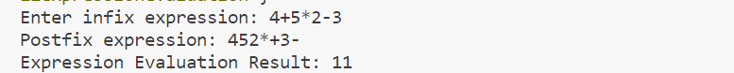

|  |
| --- |
| **Program 13** |
| **Define a structure for data having**  **dd/mm/yyyy. Provide functions for reading, displaying and comparing two dates are equal or not.** |

**Source Code:**

#include <stdio.h>

struct date

{

    int day1, month1, year1;

    int day2, month2, year2;

};

struct date d;

void insert()

{

    printf("Enter the first date in the format dd/mm/yyyy: ");

    scanf("%d/%d/%d", &d.day1, &d.month1, &d.year1);

    printf("Enter the second date in the format dd/mm/yyyy: ");

    scanf(" %d/%d/%d", &d.day2, &d.month2, &d.year2);

}

void display()

{

    printf("First Date: %d/%d/%d\n", d.day1, d.month1, d.year1);

    printf("Second Date: %d/%d/%d\n", d.day2, d.month2, d.year2);

}

void compare()

{

    if (d.day1 == d.day2 && d.month1 == d.month2 && d.year1 == d.year2)

    {

        printf("Both Date Are Same\n");

    }

    else

    {

        printf("Both Date Are Different\n");

    }

}

int main()

{

    int choice;

    while (1)

    {

        printf("\nDate Comparison Menu:\n");

        printf("1. Insert Dates\n");

        printf("2. Display Dates\n");

        printf("3. Compare Dates\n");

        printf("4. Exit\n");

        printf("Enter your choice: ");

        scanf("%d", &choice);

        switch (choice)

        {

        case 1:

            insert();

            break;

        case 2:

            display();

            break;

        case 3:

            compare();

            break;

        case 4:

            printf("Goodbye!\n");

            return 0;

        default:

            printf("Invalid choice. Please try again.\n");

        }

    }

    return 0;

}

**Output:**

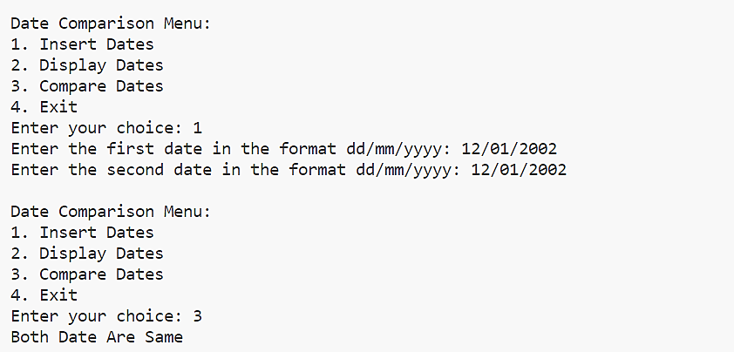

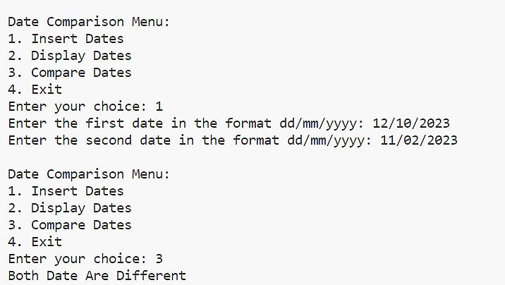

|  |
| --- |
| **Program #14** |
| **Define a structure for employees with eno,ename, esal and dno. Read n employees information and provide functions for the following:**   * 1. **Searching an employee by no**   2. **Sorting the employees by**      1. **Name**      2. **Salary**   3. **Deleting an employee** |

**Source Code:**

#include <stdio.h>

#include <string.h>

#include <process.h>

struct emp

{

    int eno, esal, dno;

    char ename[10];

};

int i, j, n;

struct emp e[20];

void read()

{

    for (i = 0; i < n; i++)

    {

        printf("\n\tEnter Details of Employee-%d", i + 1);

        printf("\n-----------------------------------------");

        printf("\nEmployee no:");

        scanf("%d", &e[i].eno);

        printf("\nEmployee name:");

        scanf("%s", &e[i].ename);

        printf("\nEmployee salary:");

        scanf("%d", &e[i].esal);

        printf("\nDno:");

        scanf("%d", &e[i].dno);

    }

}

void search()

{

    int em;

    printf("\n Enter the employee number to search:");

    scanf("%d", &em);

    for (i = 0; i < n; i++)

    {

        if (em == e[i].eno)

        {

            printf("\n SEARCHED EMPLOYEE DETAILS:");

            printf("\n --------------------------");

            printf("\n Employee No:%d", e[i].eno);

            printf("\n Employee Name:%s", e[i].ename);

            printf("\n Employee Salary:%d", e[i].esal);

            printf("\n DNo:%d", e[i].dno);

        }

    }

}

void sortname()

{

    struct emp t;

    for (i = 0; i < n; i++)

    {

        for (j = i + 1; j < n; j++)

        {

            if (strcmp(e[i].ename, e[j].ename) == 1)

            {

                t = e[i];

                e[i] = e[j];

                e[j] = t;

            }

        }

    }

    printf("\nEMPLOYEE LIST(SORTED USING NAME):");

    printf("\n---------------------------------");

    for (i = 0; i < n; i++)

    {

        printf("\nName:%s", e[i].ename);

        printf("\nEmployee No:%d", e[i].eno);

        printf("\nEmployee Dno:%d", e[i].dno);

        printf("\nEmployee Salary:%d\n", e[i].esal);

    }

}

void sortsal()

{

    struct emp t;

    for (i = 0; i < n; i++)

    {

        for (j = i + 1; j < n; j++)

        {

            if (e[i].esal > e[j].esal)

            {

                t = e[i];

                e[i] = e[j];

                e[j] = t;

            }

        }

    }

    printf("\nEMPLOYEE LIST(SORTED USING SALARY) :");

    printf("\n-----------------------------------");

    for (i = 0; i < n; i++)

    {

        printf("\nEmployee Name:%s", e[i].ename);

        printf("\nEmployee No:%d", e[i].eno);

        printf("\nDno:%d", e[i].dno);

        printf("\nEmployee Salary:%d\n", e[i].esal);

    }

}

void delet(int en)

{

    if (n == 0)

        printf("\n No Employee!!!");

    else

    {

        printf("\nLIST OF EMPLOYEES");

        printf("\n-----------------");

        for (i = 0; i < n; i++)

        {

            if (en == e[i].eno)

            {

                for (j = i; j < n - 1; j++)

                    e[j] = e[j + 1];

            }

        }

        n--;

    }

    for (i = 0; i < n; i++)

    {

        printf("\nEmployee No:%d", e[i].eno);

        printf("\nEmployee Name:%s", e[i].ename);

        printf("\nDno:%d", e[i].dno);

        printf("\nEmployee Salary:%d", e[i].esal);

    }

}

void main()

{

    int ch, ch1, en;

    printf("\n Enter number of employees:");

    scanf("%d", &n);

    read(n);

    do

    {

        printf("\n------\n MENU\n-------\n 1.Search\n 2.Sort\n 3.Delete\n 4.Exit\n Enter your choice:");

        scanf("%d", &ch);

        switch (ch)

        {

        case 1:

            search();

            break;

        case 2:

            printf("\nSorting:");

            printf("\n---------");

            printf("\n 1.Sort by name\n 2.Sort by salary\n Enter your choice: ");

            scanf("%d", &ch1);

            switch (ch1)

            {

            case 1:

                sortname();

                break;

            case 2:

                sortsal();

                break;

            }

            break;

        case 3:

            printf("\nEnter eno to delete:");

            scanf("%d", &en);

            delet(en);

            break;

        case 4:

            exit(0);

        }

    } while (1);

}

**Output:**

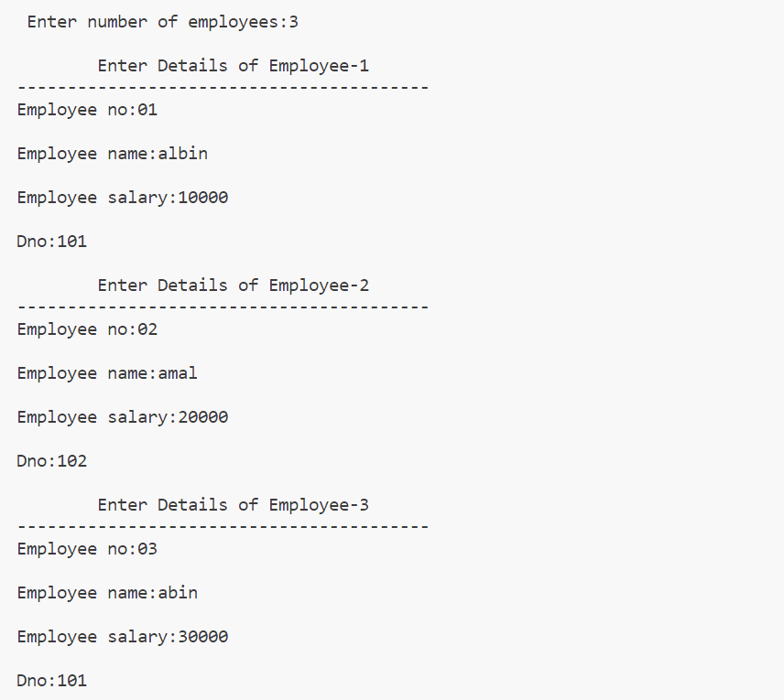

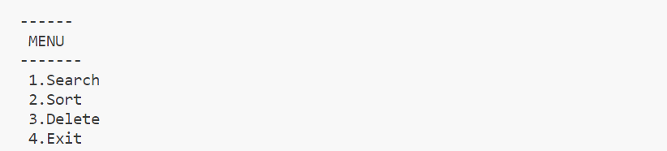

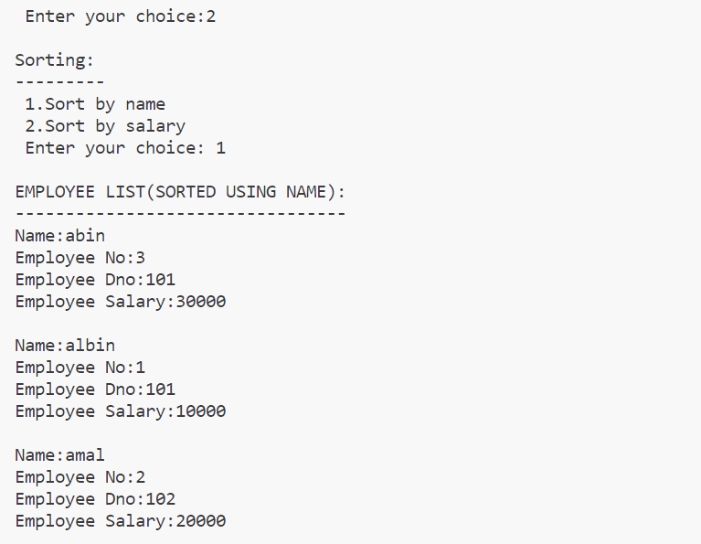

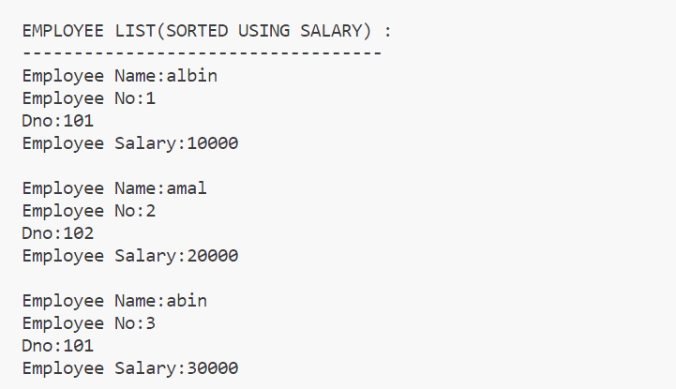

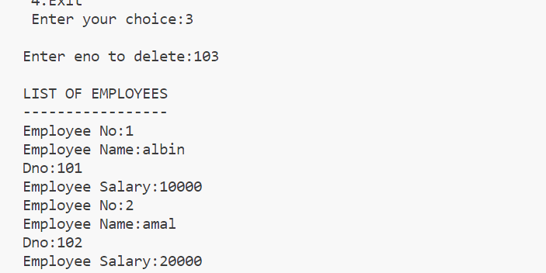

|  |
| --- |
| **Program 15** |
| **Read a polynomial and display –use array** |

**Source Code:**

#include <stdio.h>

int i;

void disp(int a[], int m)

{

  printf("\nThe polynomial is : ");

  for (i = m; i >= 0; i--)

  {

    if (a[i] != 0 && i != 0)

      printf("%dx^%d+", a[i], i);

    else if (i == 0)

      printf("%d", a[i]);

  }

}

void main()

{

  int a[20], b[30], m, n;

  printf("\nEnter degree of the polynomial : ");

  scanf("%d", &m);

  printf("\nEnter the coefficients(enter constant first): ");

  for (i = 0; i <= m; i++)

    scanf("%d", &a[i]);

  disp(a, m);

}

**Output:**

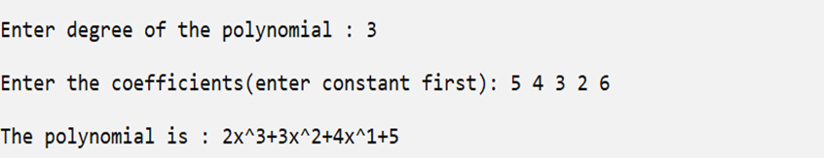

|  |
| --- |
| **Program 16** |
| **Add two polynomials –use array itself.** |

**Source Code:**

#include <stdio.h>

int main()

{

    int c1[10], e1[10], c2[10], e2[10], c3[20], e3[20];

    int i, j, n1, n2, k = 0;

    printf("Enter the number of terms for polynomial 1: ");

    scanf("%d", &n1);

    printf("Enter the polynomial 1 terms:\n");

    for (i = 0; i < n1; i++)

    {

        printf("Enter the coefficient: ");

        scanf("%d", &c1[i]);

        printf("Enter the exponent: ");

        scanf("%d", &e1[i]);

    }

    printf("Enter the number of terms for polynomial 2: ");

    scanf("%d", &n2);

    printf("Enter the polynomial 2 terms:\n");

    for (i = 0; i < n2; i++)

    {

        printf("Enter the coefficient: ");

        scanf("%d", &c2[i]);

        printf("Enter the exponent: ");

        scanf("%d", &e2[i]);

    }

    i = j = 0;

    while (i < n1 && j < n2)

    {

        if (e1[i] == e2[j])

        {

            c3[k] = c1[i] + c2[j];

            e3[k] = e1[i];

            if (e3[k] != 0)

            { // Skip terms with an exponent of zero

                k++;

            }

            i++;

            j++;

        }

        else if (e1[i] > e2[j])

        {

            c3[k] = c1[i];

            e3[k] = e1[i];

            if (e3[k] != 0)

            { // Skip terms with an exponent of zero

                k++;

            }

            i++;

        }

        else

        {

            c3[k] = c2[j];

            e3[k] = e2[j];

            if (e3[k] != 0)

            { // Skip terms with an exponent of zero

                k++;

            }

            j++;

        }

    }

    while (i < n1)

    {

        c3[k] = c1[i];

        e3[k] = e1[i];

        if (e3[k] != 0)

        { // Skip terms with an exponent of zero

            k++;

        }

        i++;

    }

    while (j < n2)

    {

        c3[k] = c2[j];

        e3[k] = e2[j];

        if (e3[k] != 0)

        { // Skip terms with an exponent of zero

            k++;

        }

        j++;

    }

    printf("Resultant polynomial after addition:\n");

    for (i = 0; i < k; i++)

    {

        if (c3[i] != 0)

        {

            if (c3[i] > 0 && i != 0)

            {

                printf(" + ");

            }

            printf("%dx^%d", c3[i], e3[i]);

        }

    }

    return 0;

}

**Output:**

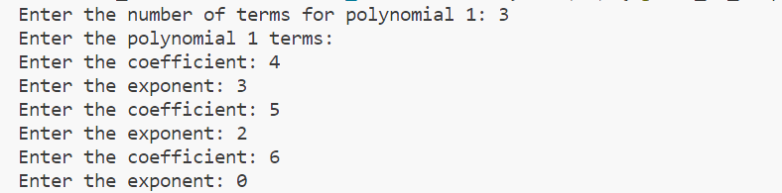

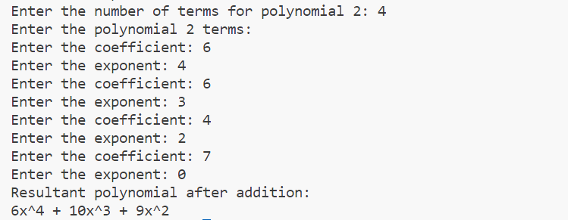

|  |
| --- |
| **Program 17** |
| **Read a polynomial and display - use structure array.** |

**Source Code:**

#include <stdio.h>

struct poly

{

    int coeff;

    int exp;

};

int main()

{

    int i, num;

    struct poly p[10];

    printf("Enter the number of terms: ");

    scanf("%d", &num);

    for (i = 0; i < num; i++)

    {

        printf("Enter the coefficient: ");

        scanf("%d", &p[i].coeff);

        printf("Enter the degree: ");

        scanf("%d", &p[i].exp);

    }

    printf("The entered polynomial is: ");

    for (i = 0; i < num; i++)

    {

        printf("%dx^%d", p[i].coeff, p[i].exp);

        if (i < num - 1)

        {

            printf(" + ");

        }

    }

    return 0;

}

**Output**

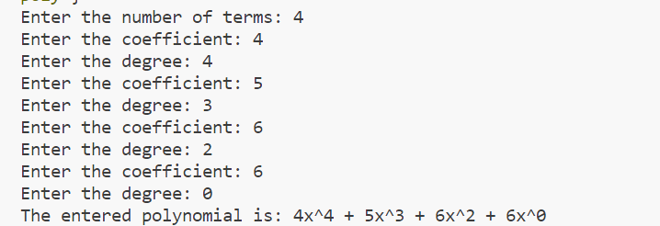

|  |
| --- |
| **Program 18** |
| **Add two polynomials use structure array.** |

**Source Code:**

#include <stdio.h>

struct poly

{

  int coe;

  int ex;

};

int main()

{

  int i, j, n1, n2, k = 0;

  struct poly p1[10], p2[10], p3[10];

  printf("enter the no of terms: ");

  scanf("%d", &n1);

  printf("enter the polynomial 1\n");

  for (i = 0; i < n1; i++)

  {

    printf("enter the coeffient: ");

    scanf("%d", &p1[i].coe);

    printf("enter the exponent: ");

    scanf("%d", &p1[i].ex);

  }

  printf("enter the no of terms: ");

  scanf("%d", &n2);

  printf("enter the polynomial 2\n");

  for (i = 0; i < n2; i++)

  {

    printf("enter the coeffient: ");

    scanf("%d", &p2[i].coe);

    printf("enter the exponent: ");

    scanf("%d", &p2[i].ex);

  }

  i = j = 0;

  while (i < n1 && j < n2)

  {

    if (p1[i].ex == p2[j].ex)

    {

      p3[k].coe = p1[i].coe + p2[i].coe;

      p3[k].ex = p1[i].ex;

      i++;

      j++;

      k++;

    }

    else if (p1[i].ex > p2[j].ex)

    {

      p3[k].coe = p1[i].coe;

      p3[k].ex = p1[i].ex;

      i++;

      k++;

    }

    else

    {

      p3[k].coe = p2[j].coe;

      p3[k].ex = p2[j].ex;

      j++;

      k++;

    }

  }

  while (i < n1)

  {

    p3[k].coe = p1[i].coe;

    p3[k].ex = p1[i].ex;

    i++;

    k++;

  }

  while (j < n2)

  {

    p3[k].coe = p2[j].coe;

    p3[k].ex = p2[j].ex;

    j++;

    k++;

  }

  printf("\n POLYNOMIALS ADDITION");

  printf("\n---------------------------------\n");

  for (i = 0; i < k; i++)

  {

    printf("%dx^%d", p3[i].coe, p3[i].ex);

    if (i < k - 1)

    {

      printf(" + ");

    }

  }

  return 0;

}

**Output:**

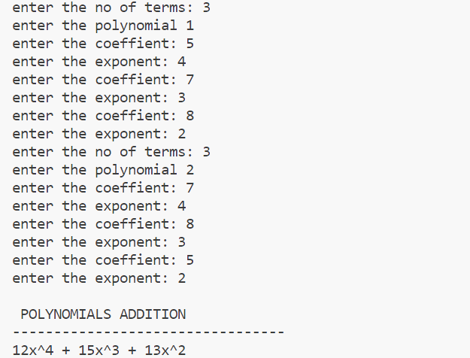

|  |
| --- |
| **Program 19** |
| **Subtract two polynomials.** |

**Source Code:**

#include<stdio.h>

struct poly{

int coe;

int ex;

};

int main()

{

int i,j,n1,n2,k=0;

struct poly p1[10],p2[10],p3[10];

printf("enter the no of terms\n");

scanf("%d",&n1);

printf("enter the polynomial 1\n");

for(i=0;i<n1;i++){

printf("enter the coeffient\n");

scanf("%d",&p1[i].coe);

printf("enter the exponent\n");

scanf("%d",&p1[i].ex);

}

printf("enter the no of terms\n");

scanf("%d",&n2);

printf("enter the polynomial 2\n");

for(i=0;i<n2;i++){

printf("enter the coeffient\n");

scanf("%d",&p2[i].coe);

printf("enter the exponent\n");

scanf("%d",&p2[i].ex);

}

i=j=0;

while(i<n1 && j<n2){

if(p1[i].ex==p2[j].ex){

p3[k].coe=p1[i].coe-p2[i].coe;

p3[k].ex=p1[i].ex;

i++;j++;k++;

}

else if(p1[i].ex>p2[j].ex){

p3[k].coe=p1[i].coe;

p3[k].ex=p1[i].ex;

i++;k++;

}

else{

p3[k].coe=p2[j].coe;

p3[k].ex=p2[j].ex;

j++;k++;

}

}

while(i<n1){

p3[k].coe=p1[i].coe;

p3[k].ex=p1[i].ex;

i++;k++;

}

while(j<n2){

p3[k].coe=p2[j].coe;

p3[k].ex=p2[j].ex;

j++;k++;

}

printf("\n POLYNOMIALS SUBSTRATION");

printf("\n---------------------------------\n");

for(i=0;i<k;i++){

printf("%dx^%d",p3[i].coe,p3[i].ex);

if (i < k - 1)

{

printf(" + ");

}

}

return 0;

}

**Output:**

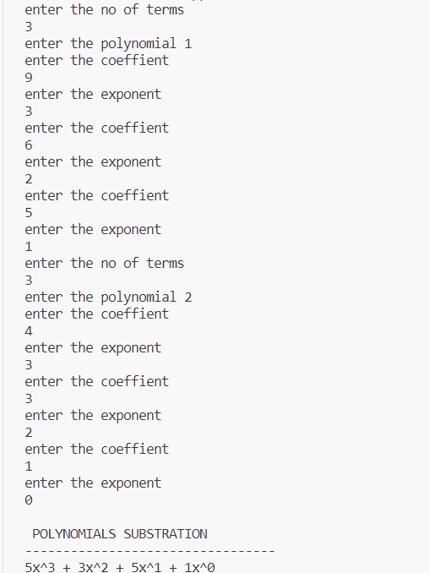



|  |
| --- |
| **Program 20** |
| **Multiply two polynomials.** |

**Source Code:**

#include <stdio.h>

struct poly

{

  int coe;

  int exp;

};

int main()

{

  struct poly poly1[10], poly2[10], product[100];

  int noOfTerms1, noOfTerms2, count = -1;

  int i, j;

  printf("\nEnter Number Of Terms Of 1st Polynomial: ");

  scanf("%d", &noOfTerms1);

  for (i = 0; i < noOfTerms1; i++)

  {

    printf("\nEnter Coefficient: ");

    scanf("%d", &poly1[i].coe);

    printf("\nEnter Exponent: ");

    scanf("%d", &poly1[i].exp);

  }

  printf("\nEnter Number Of Terms Of 2nd Polynomial: ");

  scanf("%d", &noOfTerms2);

  for (i = 0; i < noOfTerms2; i++)

  {

    printf("\nEnter Coefficient: ");

    scanf("%d", &poly2[i].coe);

    printf("\nEnter Exponent: ");

    scanf("%d", &poly2[i].exp);

  }

  for (i = 0; i < noOfTerms1; i++)

  {

    for (j = 0; j < noOfTerms2; j++)

    {

      product[++count].exp = poly1[i].exp + poly2[j].exp;

      product[count].coe = poly1[i].coe * poly2[j].coe;

    }

  }

  printf("\nThe Product Of Two Polynomials Is: \n");

  for (i = 0; i <= count; i++)

  {

    if (product[i].exp == 0)

      printf("%d ", product[i].coe);

    else if (product[i].exp == 1)

      printf("%dx ", product[i].coe);

    else

      printf("%dx^%d ", product[i].coe, product[i].exp);

    if (i != count)

      printf("+ ");

  }

  return 0;

}

**Output:**

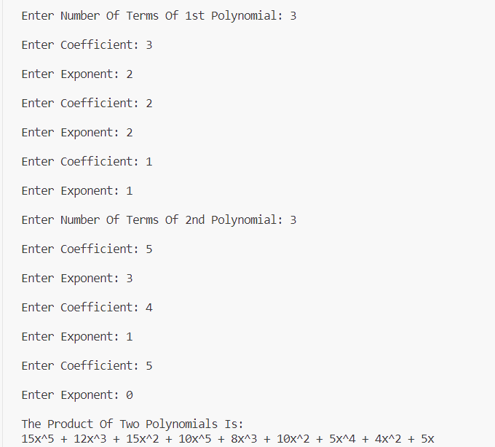

|  |
| --- |
| **Program 21** |
| **Implement a) malloc , b) calloc and c) free functions.** |

**Source Code:**

#include<stdio.h>

#include<process.h>

void main(){

int ch,n,p,i,*a;

printf("\nEnter limit:");

scanf("%d",&n);

do{

printf("\n1.malloc\n2.calloc\n3.exit\nEnter your choice:");

scanf("%d",&ch);

switch(ch){

case 1:a=(int*)malloc(n*sizeof(int));

for(i=0;i<n;i++){

printf("\n Enter %d element:",i+1);

scanf("%d",&p);

a[i]=p;

}

printf("\n Elements are:");

for(i=0;i<n;i++)

printf("%d\t",a[i]);

free(a);

break;

case 2:a=(int*)calloc(n,sizeof(int));

for(i=0;i<n;i++){

printf("\n Enter %d element:",i+1);

scanf("%d",&p);

a[i]=p;

}

printf("\n Elements are:");

for(i=0;i<n;i++)

printf("%d\t",a[i]);

free(a);

break;

case 3:exit(1);

}

}while(1);

}

**Output:**

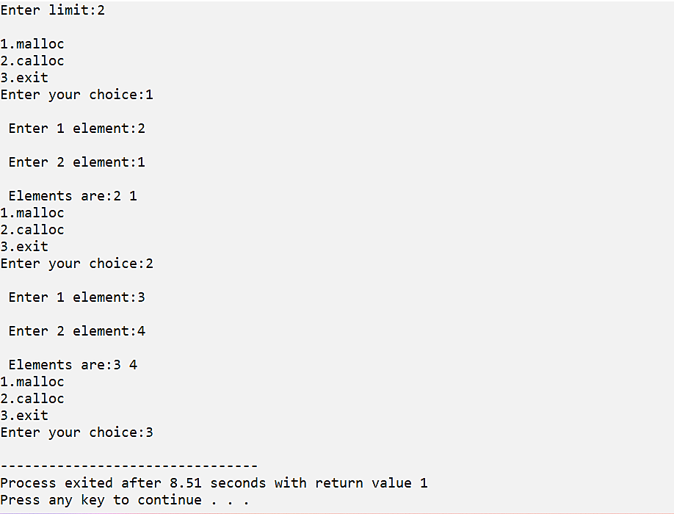

|  |
| --- |
| **Program 22** |
| **Use malloc to read n integers and find the mean.** |

**Source Code:**

#include<stdio.h>

void main(){

int n,p,sum,i,*a;

printf("\n Enter limit:");

scanf("%d",&n);

a=(int*)malloc(n*sizeof(int));

printf("\n Enter elements:");

for(i=0;i<n;i++){

scanf("%d",&p);

a[i]=p;

sum+=a[i];

}

printf("\n Elements are:");

for(i=0;i<n;i++)

printf("\t%d",a[i]);

printf("\n Mean:%d",sum);

free(a);

}

**Output:**

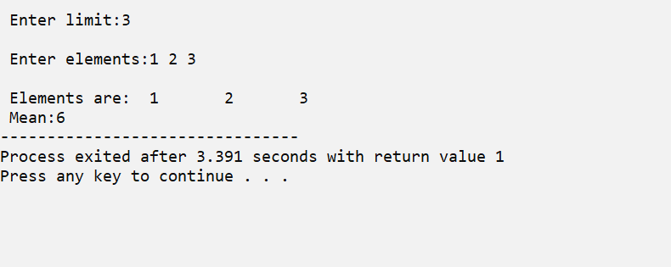

|  |
| --- |
| **Program 23** |
| **Use calloc to read n numbers and find the mode.** |

**Source Code:**

#include <stdio.h>

#include <stdlib.h>

int max_val[5];

void main()

{

  int n, *ptr, i, y;

  int x;

  printf("Enter the limit: ");

  scanf("%d", &n);

  ptr = (int *)calloc(n, sizeof(int));

  printf("Enter the values to calculate mode:\n");

  for (i = 0; i < n; i++)

  {

    scanf("%d", &ptr[i]);

  }

  printf("\n====\nMODE\n====\n");

  mode(ptr, n);

  free(ptr);

}

int mode(int ptr[], int n)

{

  int i, j, k = 0;

  int max_count = 0;

  for (i = 0; i < n; i++)

  {

    int count = 0;

    for (j = i + 1; j < n; j++)

    {

      if (ptr[i] == ptr[j])

      {

        count = count + 1;

      }

    }

    if (count > max_count)

    {

      max_count = count;

    }

  }

  for (i = 0; i < n; i++)

  {

    int count = 0;

    for (j = i + 1; j < n; j++)

    {

      if (ptr[i] == ptr[j])

    {

        count = count + 1;

      }

    }

    if (count == max_count)

    {

      printf("\n%d", ptr[i]);

    }

  }

  return 0;

}

**Output:**

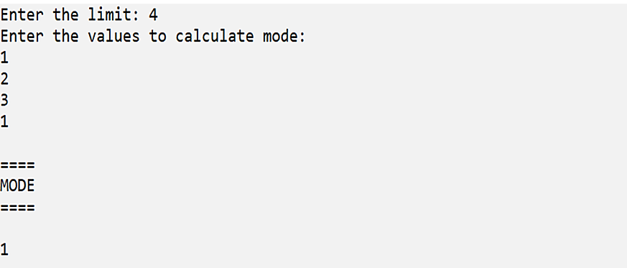

|  |
| --- |
| **Program #24** |
| **Declare a structure for Books having author_name and book_name. Create an array of books using a pointer variable. Provide functions for reading n books and displaying the same using pointers.** |

**Source Code:**

#include <stdio.h>

#include <stdlib.h>

struct book

{

    char author_name[20];

    char book_name[20];

};

struct book *a;

int i, n;

void read()

{

    a = (struct book *)malloc(sizeof(struct book));

    for (i = 0; i < n; i++)

    {

        printf("\n Enter details of book %d", i + 1);

        printf("\n ------------------------");

        printf("\n Enter book name:");

        gets(a[i].book_name);

        printf("\n Enter author name:");

        gets(a[i].author_name);

    }

}

void disp()

{

    for (i = 0; i < n; i++)

    {

        printf("\n===================");

        printf("\nDetails of book %d", i + 1);

        printf("\n===================");

        printf("\n Book name:%s", a[i].book_name);

        printf("\n Author name:%s", a[i].author_name);

    }

}

void main()

{

    printf("\n Enter no of books you want to enter:");

    scanf("%d", &n);

    getchar();

    read();

    disp();

}

**Output:**

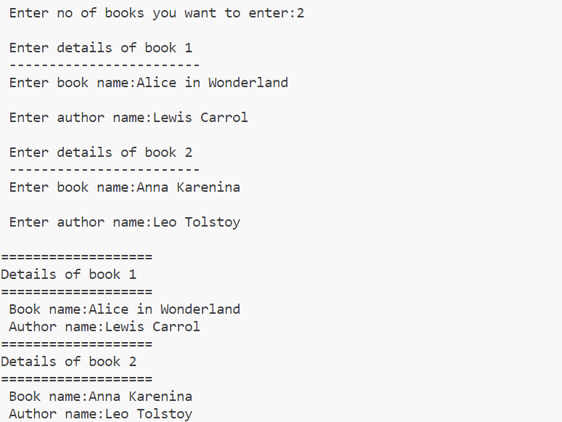

|  |
| --- |
| **Program #25** |
| **Use realloc to implement varchar for any length.** |

#include <stdio.h>

#include <stdlib.h>

#include <string.h>

int main()

{

    char *ptr;

    char str[50];

    int len, n, i;

    printf("\nEnter the string : ");

    scanf("%s", &str);

    len = strlen(str);

    ptr = (char *)malloc(len * sizeof(char));

    strcpy(ptr, str);

    printf("\nThe string using malloc is : ");

    for (i = 0; i < len; i++)

    {

        printf("%c", *(ptr + i));

    }

    printf("\n\nEnter the new size : ");

    scanf("%d", &n);

    ptr = (char *)realloc(ptr, n);

    printf("\nThe string using realloc is : ");

    for (i = 0; i < n && ptr[i] != '\0'; i++)

    {

        printf("%c", *(ptr + i));

    }

    free(ptr);

    return 0;

}

**Output:**

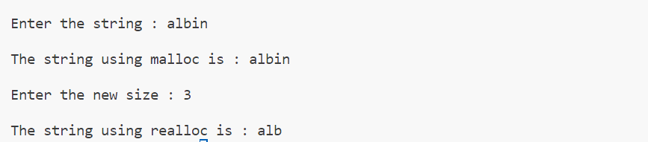

|  |
| --- |
| **Program 26** |
| **Implement Queue using array.** |

**Source Code:**

#include <stdio.h>

int q[30], n;

int f = -1, r = -1;

void enqueue(int e)

{

    if ((f == -1) && (r == -1))

    {

        f = r = 0;

        q[r] = e;

    }

    else if (r == n - 1)

        printf("\nQueue Full\n");

    else

    {

        r++;

        q[r] = e;

    }

    printf("Enqueued element is :%d\n", q[r]);

}

void dequeue()

{

    if ((f == -1) && (r == -1))

        printf("\nqueue empty!!\n");

    else if (f == r)

    {

        printf("\nDequeued element is :%d\n", q[f]);

        r = f = -1;

    }

    else

    {

        printf("\nDequeued element is :%d\n", q[f]);

        f++;

    }

}

int menu()

{

    int ch;

    printf("\n 1-ENQUEUE\n 2-DEQUEUE\n 3-EXIT\n Enter the choice: ");

    scanf("%d", &ch);

    return ch;

}

int main()

{

    int i;

    printf("\nEnter the size of queue: ");

    scanf("%d", &n);

    for (i = menu(); i != 3; i = menu())

    {

        switch (i)

        {

        case 1:

            printf("\nEnter the value to enqueue: ");

            scanf("%d", &i);

            enqueue(i);

            break;

        case 2:

            dequeue();

            break;

        default:

            printf("\nInvalid choice");

        }

    }

    return 0;

}

**Output:**

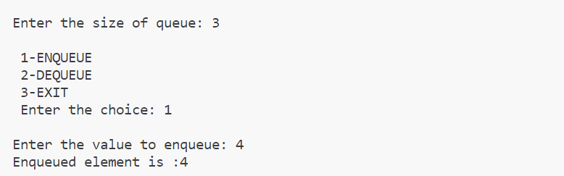

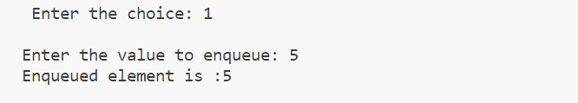

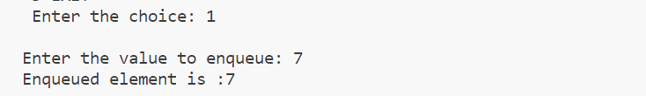

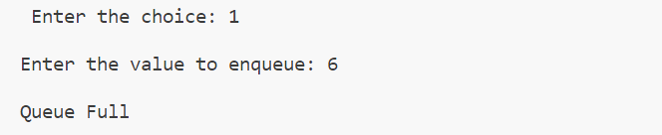

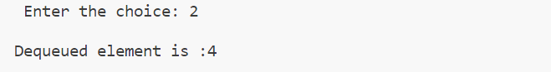

|  |
| --- |
| **Program #27** |
| **Implement priority queue.** |

**Source Code:**

#include <stdio.h>

#include <stdlib.h>

#define MAX 5

void insert_by_priority(int);

void delete_by_priority(int);

void create();

void check(int);

void display_pqueue();

int pri_que[MAX];

int front, rear;

int main()

{

    int n, ch;

    create();

    while (ch != 3)

    {

        printf("\nMENU\n=====\n1.Insert an element\n2.Display the queue\n3.Exit\n");

        printf("\nEnter your choice: ");

        scanf("%d", &ch);

        switch (ch)

        {

        case 1:

            printf("Enter the element to be inserted:");

            scanf("%d", &n);

            insert_by_priority(n);

            break;

        case 2:

            display_pqueue();

            break;

        case 3:

            exit(0);

            break;

        default:

            printf("\nEnter valid choice:\n");

        }

    }

}

void create()

{

    front = rear = -1;

}

void insert_by_priority(int data)

{

    if (rear >= MAX - 1)

    {

        printf("\nQueue overflow no more elements can be inserted");

        return;

    }

    if ((front == -1) && (rear == -1))

    {

        front++;

        rear++;

        pri_que[rear] = data;

        return;

    }

    else

        check(data);

    rear++;

}

void check(int data)

{

    int i, j;

    for (i = 0; i <= rear; i++)

    {

        if (data >= pri_que[i])

        {

            for (j = rear + 1; j > i; j--)

            {

                pri_que[j] = pri_que[j - 1];

            }

            pri_que[i] = data;

            return;

        }

    }

    pri_que[i] = data;

}

void delete_by_priority(int data)

{

    int i;

    if ((front == -1) && (rear == -1))

    {

        printf("\nQueue is empty no elements to delete");

        return;

    }

    for (i = 0; i <= rear; i++)

    {

        if (data == pri_que[i])

        {

            for (; i < rear; i++)

            {

                pri_que[i] = pri_que[i + 1];

            }

            pri_que[i] = -99;

            rear--;

            if (rear == -1)

                front = -1;

            return;

        }

    }

    printf("\n%d not found in queue to delete", data);

}

void display_pqueue()

{

    if ((front == -1) && (rear == -1))

    {

        printf("\nQueue is empty");

        return;

    }

    for (; front <= rear; front++)

    {

        printf(" %d ", pri_que[front]);

    }

    front = 0;

}

**Output:**

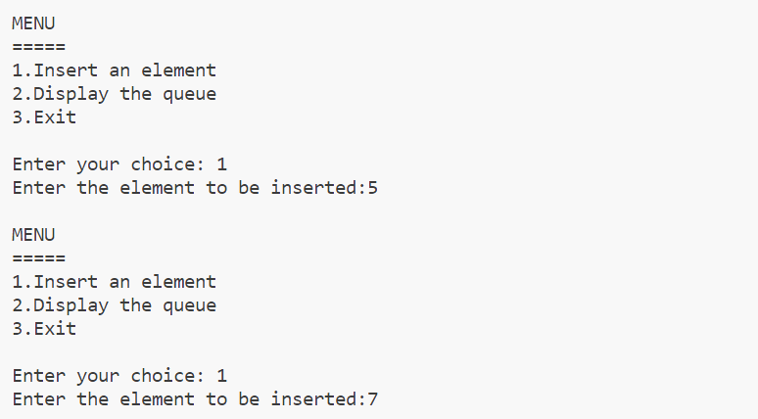

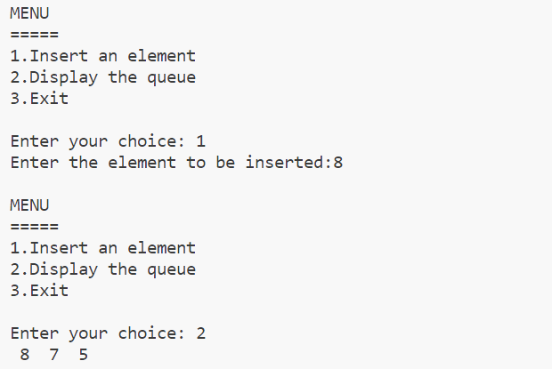

|  |
| --- |
| **Program 28** |
| **Demonstrate a linked list creation and display.** |

**Source Code:**

#include <stdio.h>

#include <malloc.h>

struct node

{

    int data;

    struct node *next;

};

struct node *head = NULL;

void insert(int e)

{

    struct node *t;

    if (head == NULL)

    {

        head = (struct node *)malloc(sizeof(struct node));

        head->data = e;

        head->next = NULL;

    }

    else

    {

        t = head;

        while (t->next != NULL)

        {

            t = t->next;

        }

        t->next = (struct node *)malloc(sizeof(struct node));

        t->next->data = e;

        t->next->next = NULL;

    }

    printf("\n%d is inserted", e);

}

void disp()

{

    struct node *t;

    if (head == NULL)

    {

        printf("Linked List Is Empty");

    }

    else

    {

        t = head;

        printf("\nLinked list elements are:\n");

        while (t != NULL)

        {

            printf("%d\t", t->data);

            t = t->next;

        }

        printf("\n");

    }

}

int main()

{

disp();

    insert(10);

    insert(20);

    insert(30);

    disp();

    return 0;

}

**Output:**

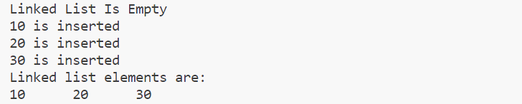

|  |
| --- |
| **Program 29** |
| **Write a program with functions  to insert a new node**   * 1. **At the beginning of a Singly Linked List.**   2. **At the end of the linked list**   3. **After a specified element in a linked list.** |

**Source Code:**

#include <stdio.h>

#include <stdlib.h>

struct node

{

    int data;

    struct node *next;

};

struct node *head = NULL;

void atend(int e)

{

    if (head == NULL)

    {

        head = (struct node *)malloc(sizeof(struct node));

        head->data = e;

        head->next = NULL; // Initialize next to NULL

    }

    else

    {

        struct node *t = head;

        while (t->next != NULL)

        {

            t = t->next;

        }

        t->next = (struct node *)malloc(sizeof(struct node));

        t->next->data = e;

        t->next->next = NULL;

    }

}

void atbegin(int e)

{

    struct node *newnode = (struct node *)malloc(sizeof(struct node));

    if (newnode == NULL)

    {

        printf("Memory allocation failed\n");

        exit(1);

    }

    newnode->data = e;

    newnode->next = head;

    head = newnode;

}

void afterelement(int e, int n)

{

    struct node *t, *a;

    t = head;

    while ((t->next != NULL) && (t->data != n))

    {

        t = t->next;

    }

    if ((t->next == NULL) && (t->data != n))

    {

        printf("element not found");

    }

    else

    {

        a = (struct node *)malloc(sizeof(struct node));

        a->data = e;

        a->next = t->next;

        t->next = a;

    }

}

void disp()

{

    struct node *t = head;

    if (head == NULL)

    {

        printf("Linked list is empty\n");

    }

    else

    {

        while (t != NULL)

        {

            printf("%d\t", t->data);

            t = t->next;

        }

        printf("\n");

    }

}

int menu()

{

    int ch;

    printf("\n 1-At Begining \n 2-At End \n 3-After Element \n 4-Display \n 5-Exit \n Enter your choice: ");

    scanf("%d", &ch);

    return ch;

}

int elemnt()

{

    int n;

    printf("Enter the element: ");

    scanf("%d", &n);

    return n;

}

int main()

{

    int ch;

    int n, m;

    for (ch = menu(); ch != 5; ch = menu())

    {

        switch (ch)

        {

        case 1:

            n = elemnt();

            atbegin(n);

            break;

        case 2:

            n = elemnt();

            atend(n);

            break;

        case 3:

            n = elemnt();

            printf("\nEnter the elemnt after which you want to enter new element: ");

            scanf("%d", &m);

            afterelement(n, m);

            break;

        case 4:

            disp();

            break;

        default:

            printf("invalid choice");

            break;

        }

    }

    return 0;

}

**Output:**

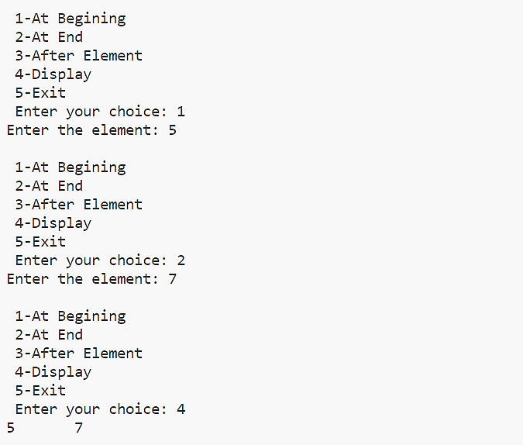



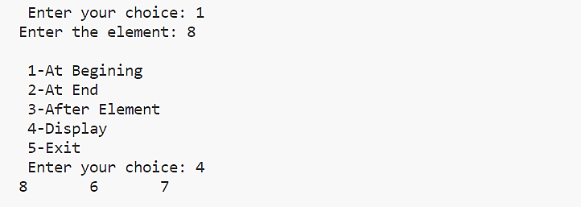

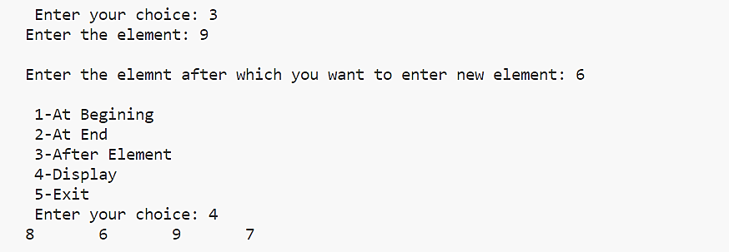

|  |
| --- |
| **Program #30** |
| **Write a program with functions to delete a node**   * 1. **From the beginning of the linked list**   2. **From the end of the linked list**   3. **The node with specified data element** |

**Source Code:**

#include<stdio.h>

#include<stdlib.h>

#include<process.h>

struct node{

int info;

struct node *next;

};

struct node *first=NULL,*last=NULL;

void create(){

struct node *temp=(struct node*)malloc(sizeof(struct node));

int n;

printf("\n Enter value:");

scanf("%d",&n);

temp->info=n;

temp->next=NULL;

if(first==NULL){

first=temp;

last=first;

}

else{

last->next=temp;

last=temp;

}

}

void delet(){

struct node *prev=NULL,*cur=NULL,*t;

int count=1,pos,ch;

printf("\n 1.DELETE AT 1ST NODE\n 2.DELETE AT LAST NODE\n 3.DELETE AN

SPECIFIC ELEMENT\n CHOOSE YOUR OPTION:");

scanf("%d",&ch);

switch(ch){

case 1:if(first!=NULL){

printf("\n deleted element:%d",first->info);

first=first->next;

}

else

printf("\n not possible");

break;

case 2:t=first;

while(t->next->next!=NULL){

t=t->next;

}

t->next=NULL;

printf("\nNode Deleted ");

break;

case 3: t=first;

int n;

printf("\nEnter the data to be deleted:");

scanf("%d",&n);

while(t->next!=NULL && t->next->info!=n){

t=t->next;

}

if(t->next==NULL){

printf("\nelement not found not found!");

}

else{

t->next=t->next->next;

}

printf("\n Node Deleted");

break;

}

}

void display()

{

struct node *t = first;

if(t == NULL)

{

printf("List is Empty\n");

}

else{

printf("\n Elements:\t");

while (t != NULL)

{

printf("%d\t",t->info);

t = t->next;

}

printf("\n\n");

}

}

void main(){

int e,c;

do{

printf("\n 1.Create\n 2.Delete\n 3.Display\n 4.Exit\n Choose your option:");

scanf("%d",&c);

switch(c){

case 1: create();

break;

case 2: delet();

break;

case 3:display();

break;

case 4:exit(1);

break;

}

}while(1);

}

**Output:**

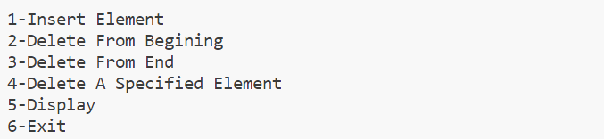

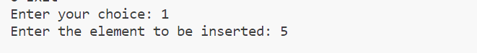

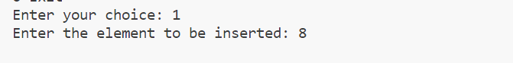

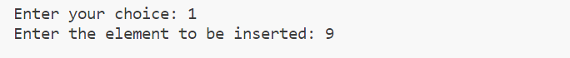





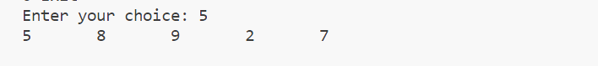

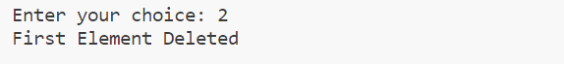

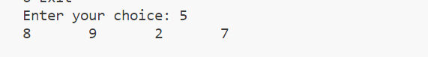

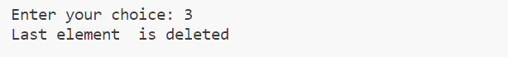

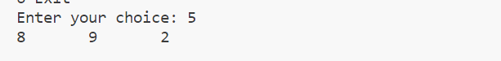

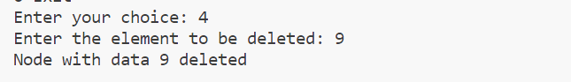



|  |
| --- |
| **Program 31** |
| **Write a program to create a singly linked list of n nodes and display it in reverse order.** |

**Source Code:**

#include <stdio.h>

#include <malloc.h>

struct node

{

    int data;

    struct node *next;

};

struct node *head = NULL;

void insert(int e)

{

    struct node *newnode = (struct node *)malloc(sizeof(struct node));

    newnode->data = e;

    newnode->next = NULL;

    if (head == NULL)

    {

        head = newnode;

    }

    else

    {

        struct node *t;

        t = head;

        while (t->next != NULL)

        {

            t = t->next;

        }

        t->next = newnode;

    }

    printf("\n%d is inserted", newnode->data);

}

void reverse()

{

    struct node *t = head;

    struct node *prev = NULL, *next = NULL;

    while (t != NULL)

    {

        next = t->next;

        t->next = prev;

        prev = t;

        t = next;

    }

    head = prev;

    printf("\nElements Are Reversed");

}

void display()

{

    if (head == NULL)

    {

        printf("\nLinked List Is Empty");

    }

    else

    {

        struct node *t = head;

        while (t != NULL)

        {

            printf("%d\t", t->data);

            t = t->next;

        }

        printf("\n");

    }

}

int menu()

{

    int ch;

    printf("\nEnter Your Choice \n1-Insert \n2-Display \n3-Reverse \n4-Exit\n");

    scanf("%d", &ch);

    return ch;

}

int main()

{

    int ch, e;

    for (ch = menu(); ch != 4; ch = menu())

    {

        switch (ch)

        {

        case 1:

            printf("\nEnter The Element To Insert: ");

            scanf("%d", &e);

            insert(e);

            break;

        case 2:

            display();

            break;

        case 3:

            reverse();

            break;

        default:

            printf("Invalid choice!");

            break;

        }

    }

}

**Output:**

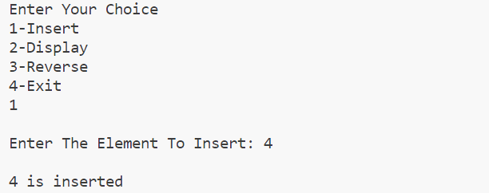

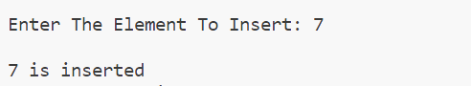

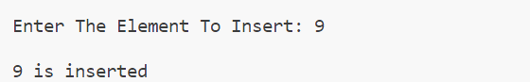

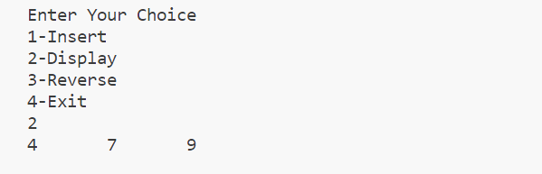

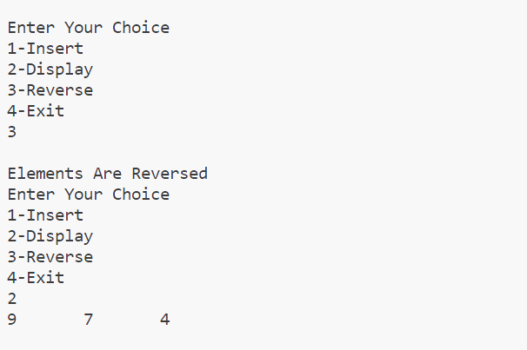

|  |
| --- |
| **Program 32** |
| **Sort the elements in a linked list using**   * 1. **changing the values (swapping the values)**   2. **Changing the address (Swapping the address).** |

**Source Code:**

#include <stdio.h>

#include <stdlib.h>

struct node

{

    int data;

    struct node *next;

};

struct node *ptr = NULL;

struct node *head = NULL;

void insert(int val)

{

    if (head == NULL)

    {

        head = (struct node *)malloc(sizeof(struct node));

        head->data = val;

        head->next = NULL;

    }

    else

    {

        ptr = head;

        while (ptr->next != NULL)

        {

            ptr = ptr->next;

        }

        ptr->next = (struct node *)malloc(sizeof(struct node));

        ptr->next->data = val;

        ptr->next->next = NULL;

    }

}

void sortList()

{

    struct node *current = head, *index = NULL;

    int temp;

    if (head == NULL)

    {

        return;

    }

    else

    {

        while (current != NULL)

        {

            index = current->next;

            while (index != NULL)

            {

                if (current->data > index->data)

                {

                    temp = current->data;

                    current->data = index->data;

                    index->data = temp;

                }

                index = index->next;

            }

            current = current->next;

        }

    }

}

void Sortaddress()

{

    int swapp, i;

    struct node *ptr1;

    struct node *lptr = NULL;

    if (head == NULL)

        return;

    do

    {

        swapp = 0;

        ptr1 = head;

        while (ptr1->next != lptr)

        {

            if (ptr1->data > ptr1->next->data)

            {

                swap(ptr1, ptr1->next);

                swapp = 1;

            }

            ptr1 = ptr1->next;

        }

        lptr = ptr1;

    } while (swapp);

}

void swap(struct node *a, struct node *b)

{

    int temp = a->data;

    a->data = b->data;

    b->data = temp;

}

void display()

{

    struct node *ptr = head;

    while (ptr != NULL)

    {

        printf("%d\t", ptr->data);

        ptr = ptr->next;

    }

    printf("\n");

}

void main()

{

    int ch, val;

    while (1)

    {

        printf("\n1.Insert.\n2.Display linked list\n3.Sort by swapping values\n4.Sort by swapping address\n5.Exit\nEnter your choice:");

        scanf("%d", &ch);

        switch (ch)

        {

        case 1:

            printf("Enter the number to insert :");

            scanf("%d", &val);

            insert(val);

            break;

        case 2:

            display();

            break;

        case 3:

            sortList();

            printf("\nSorted by swapping values");

            break;

        case 4:

            Sortaddress();

            printf("\nSorted by swapping address");

            break;

        case 5:

            exit(0);

            break;

        default:

        {

            printf("Wrong choice\n");

            break;

        }

        }

    }

}

**Output:**

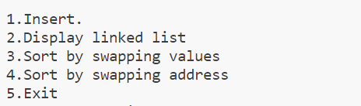

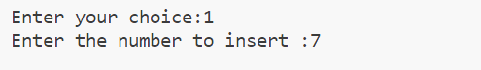

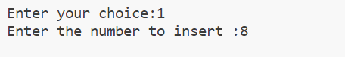

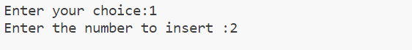



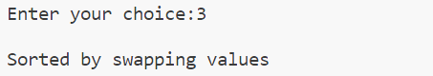

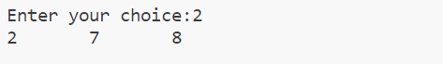

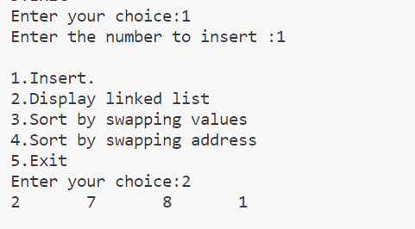

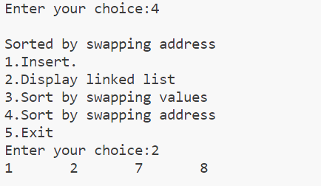

|  |
| --- |
| **Program 33** |
| **Polynomial using linked list - addition and multiplication.** |

**Source Code:**

#include <stdio.h>

#include <stdlib.h>

struct node

{

    float coeff;

    int expo;

    struct node *next;

};

typedef struct node node;

struct node *insert(struct node *head, float co, int ex)

{

    struct node *temp;

    struct node *newP = malloc(sizeof(struct node));

    newP->coeff = co;

    newP->expo = ex;

    newP->next = NULL;

    if (head == NULL || ex > head->expo)

    {

        newP->next = head;

        head = newP;

    }

    else

    {

        temp = head;

        while (temp->next != NULL && temp->next->expo >= ex)

            temp = temp->next;

        newP->next = temp->next;

        temp->next = newP;

    }

    return head;

}

struct node *create(struct node *head)

{

    int n, i;

    float coeff;

    int expo;

    printf("Enter the number of terms: ");

    scanf("%d", &n);

    for (i = 0; i < n; i++)

    {

        printf("Enter the coefficient for term %d: ", i + 1);

        scanf("%f", &coeff);

        printf("Enter the exponent for term %d: ", i + 1);

        scanf("%d", &expo);

        head = insert(head, coeff, expo);

    }

    return head;

}

void disp(struct node *head)

{

    if (head == NULL)

        printf("No Polynomial.");

    else

    {

        struct node *temp = head;

        while (temp != NULL)

        {

            printf("(%.0fx^%d)", temp->coeff, temp->expo);

            temp = temp->next;

            if (temp != NULL)

                printf(" + ");

            else

                printf("\n");

        }

    }

}

void polyAdd(struct node *head1, struct node *head2)

{

    struct node *ptr1 = head1;

    struct node *ptr2 = head2;

    struct node *sum = NULL;

    while (ptr1 != NULL && ptr2 != NULL)

    {

        if (ptr1->expo == ptr2->expo)

        {

            sum = insert(sum, ptr1->coeff + ptr2->coeff, ptr1->expo);

            ptr1 = ptr1->next;

            ptr2 = ptr2->next;

        }

        else if (ptr1->expo > ptr2->expo)

        {

            sum = insert(sum, ptr1->coeff, ptr1->expo);

            ptr1 = ptr1->next;

        }

        else if (ptr1->expo < ptr2->expo)

        {

            sum = insert(sum, ptr2->coeff, ptr2->expo);

            ptr2 = ptr2->next;

        }

    }

    while (ptr1 != NULL)

    {

        sum = insert(sum, ptr1->coeff, ptr1->expo);

        ptr1 = ptr1->next;

    }

    while (ptr2 != NULL)

    {

        sum = insert(sum, ptr2->coeff, ptr2->expo);

        ptr2 = ptr2->next;

    }

    printf("\n*****************");

    printf("\nAdded polynomial");

    printf("\n*****************\n");

    disp(sum);

}

node *polyMult(node *head1, node *head2, node *pro)

{

    node *ptr1 = head1;

    node *ptr2 = head2;

    // Check if first or second polynomial is NULL

    if (head1 == NULL || head2 == NULL)

    {

        printf("\nNo polynomial\n");

        return;

    }

    // Multiplication of two polynomials

    while (ptr1 != NULL)

    {

        while (ptr2 != NULL)

        {

            float coeffPro = ptr1->coeff * ptr2->coeff;

            int expoSum = ptr1->expo + ptr2->expo;

            pro = insert(pro, coeffPro, expoSum);

            ptr2 = ptr2->next;

        }

        ptr1 = ptr1->next;

        ptr2 = head2;

    }

    return pro;

}

node *addLikeTerms(node *pro, node *res)

{

    node *temp1, *temp2;

    temp1 = pro;

    while (temp1->next != NULL)

    {

        temp2 = temp1->next;

        while (temp2 != NULL)

        {

            if (temp1->expo == temp2->expo)

            {

                float coeffSum = temp1->coeff + temp2->coeff;

                res = insert(res, coeffSum, temp1->expo);

                temp1 = temp1->next;

                break;

            }

            else

            {

                res = insert(res, temp1->coeff, temp1->expo);

                break;

            }

            temp2 = temp2->next;

        }

        temp1 = temp1->next;

    }

    res = insert(res, temp1->coeff, temp1->expo);

    return res;

}

void main()

{

    struct node *head1 = NULL;

    struct node *head2 = NULL;

    node *pro = NULL;

    node *res = NULL;

    printf("\nEnter the First polynomial");

    printf("\n========================\n");

    head1 = create(head1);

    printf("\nEnter the second polynomial");

    printf("\n=========================\n");

    head2 = create(head2);

    printf("\n******************");

    printf("\n First polynomial");

    printf("\n******************\n");

    disp(head1);

    printf("\n*******************");

    printf("\n Second polynomial");

    printf("\n*******************\n");

    disp(head2);

    polyAdd(head1, head2);

    pro = polyMult(head1, head2, pro);

    res = addLikeTerms(pro, res);

    printf("\n********");

    printf("\nProduct");

    printf("\n********\n");

    disp(res);

}

**Output:**

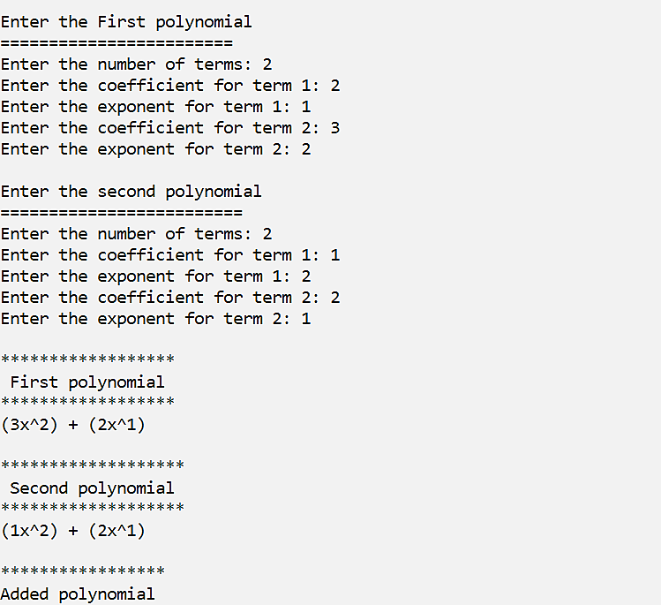

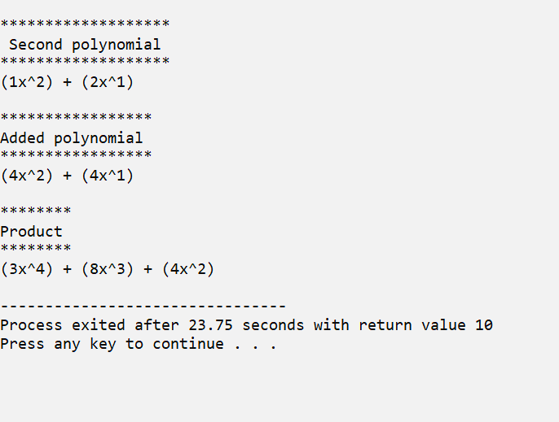

**Linked list using names - insert, delete, display, sort, reverse, count.**

**.**

**Date:**

**Program #34**

**Source Code:**

#include <stdio.h>

#include <string.h>

#include <stdlib.h>

struct node

{

    char data[20];

    struct node *next;

};

typedef struct node node;

node *head = NULL;

void insert(char e[])

{

    if (head == NULL)

    {

        head = (node *)malloc(sizeof(node));

        strcpy(head->data, e);

        head->next = NULL;

    }

    else

    {

        node *t = head;

        while (t->next != NULL)

        {

            t = t->next;

        }

        t->next = (node *)malloc(sizeof(node));

        strcpy(t->next->data, e);

        t->next->next = NULL;

    }

}

void delete_elem(char e[])

{

    node *t;

    int f = 0;

    if (head == NULL)

    {

        printf("\nList is Empty\n");

    }

    else if (strcmp(head->data, e) == 0)

    {

        head = head->next;

    }

    else

    {

        t = head;

        while (t->next != NULL)

        {

            if (strcmp(t->next->data, e) == 0)

            {

                t->next = t->next->next;

                f = 1;

                break;

            }

            t = t->next;

        }

        if (f == 0)

        {

            printf("\n%s not found\n", e);

        }

    }

}

void display()

{

    node *t = head;

    if (t == NULL)

    {

        printf("\nList is Empty\n");

        return;

    }

    printf("\nNames in the linked list are:");

    while (t != NULL)

    {

        printf("\t%s", t->data);

        t = t->next;

    }

    printf("\n\n");

}

void sort()

{

    node *temp1 = head, *temp2;

    char elem[20];

    if (head == NULL)

    {

        printf("\nList is empty\n");

        return;

    }

    while (temp1 != NULL)

    {

        temp2 = temp1->next;

        while (temp2 != NULL)

        {

            if (strcmp(temp1->data, temp2->data) > 0)

            {

                strcpy(elem, temp1->data);

                strcpy(temp1->data, temp2->data);

                strcpy(temp2->data, elem);

            }

            temp2 = temp2->next;

        }

        temp1 = temp1->next;

    }

    display();

}

void reverse(node *tmp)

{

    if (tmp == NULL)

    {

        return;

    }

    else

    {

        reverse(tmp->next);

    }

    printf("\t%s", tmp->data);

}

void count()

{

    node *tmp = head;

    int count = 0;

    while (tmp != NULL)

    {

        count++;

        tmp = tmp->next;

    }

    printf("\nNumber of elements in the linked list: %d", count);

}

int main()

{

    int ch;

    char e[20];

    do

    {

        printf("\nLinked list\n============\n 1.Insertion\n 2.Deletion \n 3.Display\n 4.Sort\n 5.Reverse \n 6.Count\n 7.Exit\n Enter your choice: ");

        scanf("%d", &ch);

        switch (ch)

        {

        case 1:

            fflush(stdin);

            printf("\nEnter the name to insert: ");

            gets(e);

            insert(e);

            break;

        case 2:

            fflush(stdin);

            printf("\nEnter the name you want to delete: ");

            gets(e);

            delete_elem(e);

            break;

        case 3:

            display();

            break;

        case 4:

            sort();

            break;

        case 5:

            if (head == NULL)

                printf("\nList is empty\n");

            else

            {

                printf("\nNames in the linked list in reverse order:");

                reverse(head);

            }

            break;

        case 6:

            count();

            break;

        case 7:

            exit(0);

            break;

        default:

            printf("\nInvalid choice!\n");

            break;

        }

    } while (ch != 7);

    return 0;

}

**Output:**

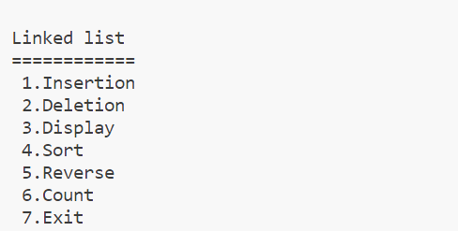

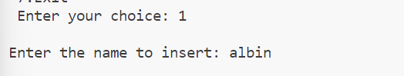

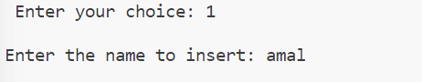

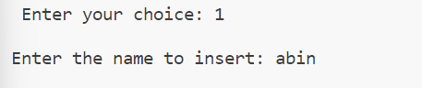

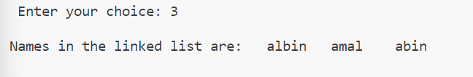

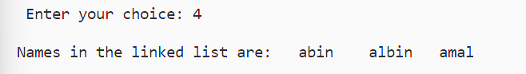



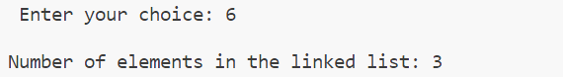

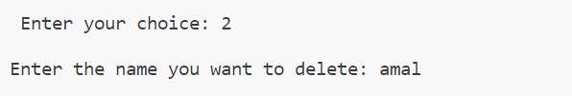

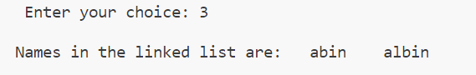

|  |
| --- |
| **Program #35** |
| **Linked Stack.** |

**Source Code:**

#include<stdio.h>

#include<stdlib.h>

#include<process.h>

struct stack{

int data;

struct stack *next;

};

struct stack *top=NULL;

typedef struct stack stack;

void push(int e){

stack *t;

t=(stack *)malloc(sizeof(stack));

t->data=e;

t->next=top;

top=t;

}

void disp(){

stack *t;

if(top==NULL){

printf("\n Stack empty");

}

else{

t=top;

printf("\n Elements :");

while(t!=NULL){

printf("\t%d",t->data);

t=t->next;

}

}

}

void pop(){

if(top==NULL){

printf("\n Stack empty");

}

else{

printf("Deleted element :%d",top->data);

top=top->next;

}

}

void main(){

int ch,e;

printf("\n LINKED STACK\n--------------\n");

do{

printf("\n1.push\n2.pop\n3.display\n4.exit\n choose your option:");

scanf("%d",&ch);

switch(ch){

case 1:printf("\n enter element:");

scanf("%d",&e);

push(e);

break;

case 2:pop();

break;

case 3:disp();

break;

case 4:exit(1);

break;

}

}while(1);

}

**Output:**

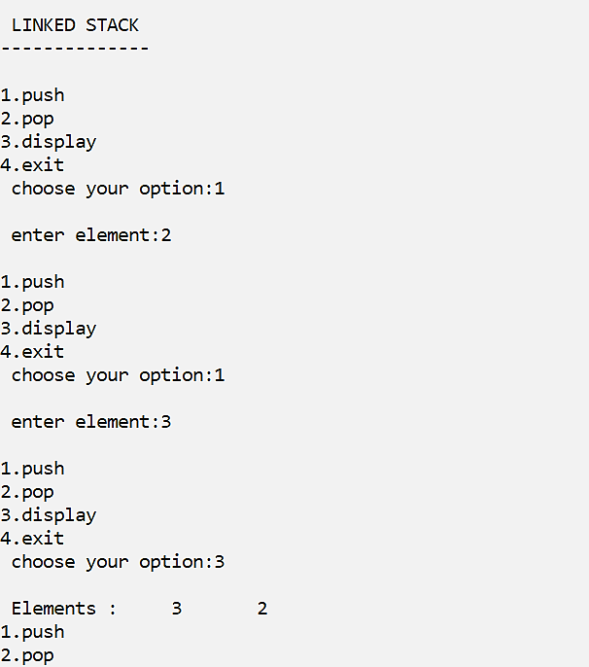

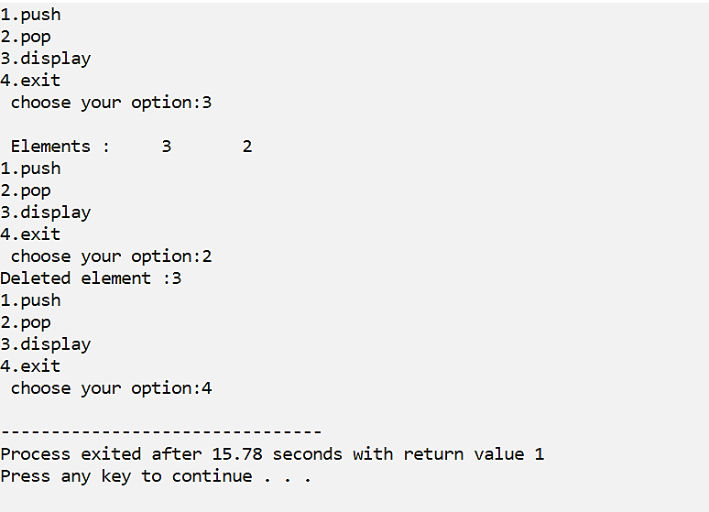

**Linked Queue.**

**Date:**

**Program #36**

**Source Code:**

#include<stdio.h>

#include<stdlib.h>

#include<process.h>

struct queue{

int data;

struct queue *next;

};

struct queue *f=NULL,*r=NULL;

typedef struct queue queue;

void enqueue(int e){

queue *t;

t=(queue *)malloc(sizeof(queue));

t->data=e;

t->next=NULL;

if(f==NULL){

f=t;

r=t;

}

else{

r->next=t;

r=r->next;

}

}

void disp(){

queue *t;

if(f==NULL){

printf("\n queue empty");

}

else{

t=f;

printf("\n Elements are:");

while(t!=NULL){

printf("\t%d",t->data);

t=t->next;

}

}

}

void dequeue(){

if(f==NULL){

printf("\n queue empty");

}

else{

printf("Deleted element :%d",f->data);

f=f->next;

if(f==NULL)

r=NULL;

}

}

void main(){

int ch,e;

printf("\n LINKED QUEUE\n----------------\n");

do{

printf("\n1.Enqueue\n2.Dequeue\n3.Display\n4.Exit\n Choose your option:");

scanf("%d",&ch);

switch(ch){

case 1:printf("\n enter element:");

scanf("%d",&e);

enqueue(e);

break;

case 2:dequeue();

break;

case 3:disp();

break;

case 4:exit(1);

break;

}

}while(1);

}

**Output:**

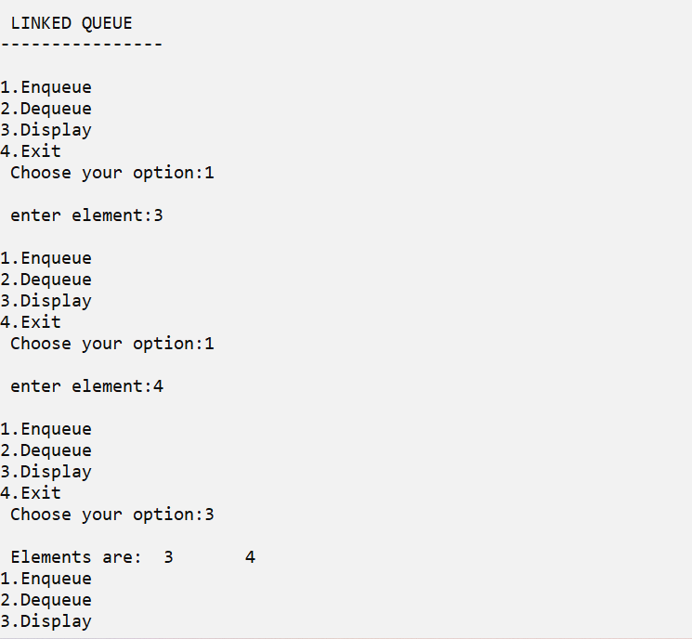

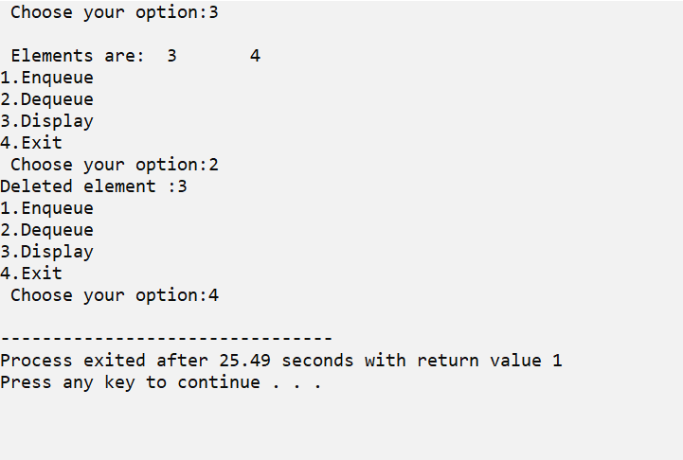

**Circular Linked List.**

**Date:**

**Program #37**

**Source Code:**

#include <stdio.h>

#include <stdlib.h>

struct node {

int data;

struct node *next;

};

typedef struct node clist;

clist *head = NULL;

void insertion(int a) {

clist *t;

if(head == NULL) {

head = (clist *)malloc(sizeof(clist));

head->data = a;

head->next = head;

}

else {

t = head;

while(t->next != head) {

t = t->next;

}

t->next = (clist *)malloc(sizeof(clist));

t->next->data = a;

t->next->next = head;

}

}

void disp() {

clist *t;

t = head;

if(t == NULL) {

printf("Empty C List");

}

else {

do {

printf("%d\t",t->data);

t = t->next;

}while(t != head);

}

}

int main()

{

int ch,e;

printf("\n CIRCULAR LINKED LIST \n---------------------\n");

do{

printf("\n1.Insertion\n2.Display\n3.Exit\n Choose your option:");

scanf("%d",&ch);

switch(ch){

case 1:printf("\n enter element:");

scanf("%d",&e);

insertion(e);

break;

case 2:disp();

break;

case 3:exit(1);

}

}while(1);

return 0;

}

**Output:**

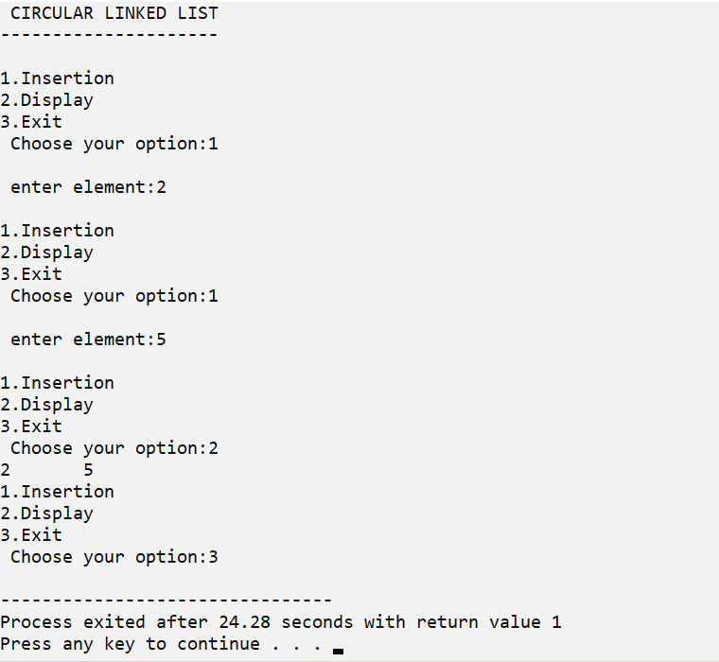

**Circular Linked Queue.**

**Date:**

**Program #38**

**Source Code:**

#include<stdio.h>

#include<stdlib.h>

struct node

{

int data;

struct node* next;

};

struct node *f = NULL;

struct node *r = NULL;

void enqueue(int d) //Insert elements in Queue

{

struct node* n;

n = (struct node*)malloc(sizeof(struct node));

n->data = d;

n->next = NULL;

if((r==NULL)&&(f==NULL))

{

f = r = n;

r->next = f;

}

else

{

r->next = n;

r = n;

n->next = f;

}

}

void dequeue() // Delete an element from Queue

{

struct node* t;

t = f;

if((f==NULL)&&(r==NULL))

printf("\nQueue is Empty");

else if(f == r){

f = r = NULL;

free(t);

}

else{

f = f->next;

r->next = f;

free(t);

}

}

void print(){ // Print the elements of Queue

struct node* t;

t = f;

if((f==NULL)&&(r==NULL))

printf("\nQueue is Empty");

else{

do{

printf("\t%d",t->data);

t = t->next;

}while(t != f);

}

}

int main()

{

int opt,n,i,data;

printf("CIRCULAR LINKED QUEUE\n----------------------\n");

do{

printf("\n1.Enqueue\n2.Display\n3.Deletion\n4.Exit\nChoose your option:");

scanf("%d",&opt);

switch(opt){

case 1:

printf("\nEnter the number of data:");

scanf("%d",&n);

printf("\nEnter your data:");

i=0;

while(i<n){

scanf("%d",&data);

enqueue(data);

i++;

}

break;

case 2:

print();

break;

case 3:

dequeue();

break;

case 4:exit(1);

break;

default:

printf("\nIncorrect Choice");

}

}while(opt!=0);

return 0;

}

**Output:**

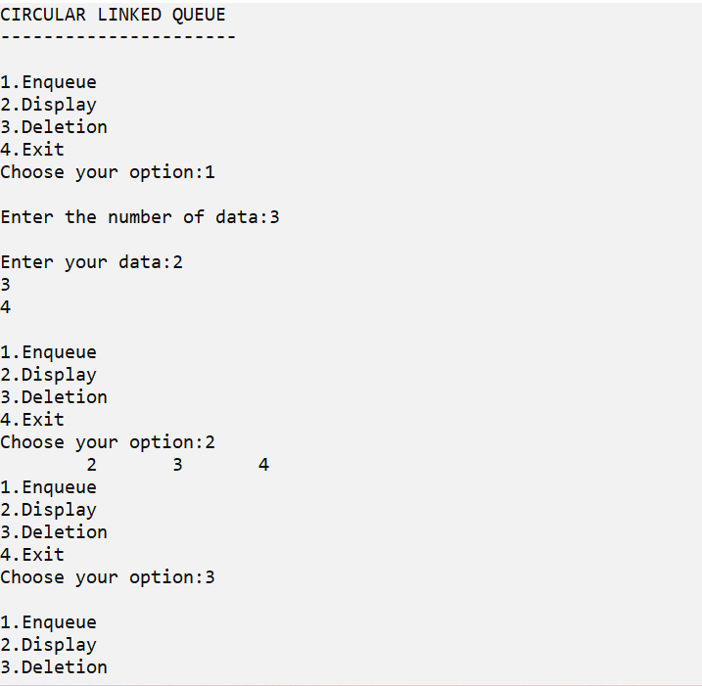

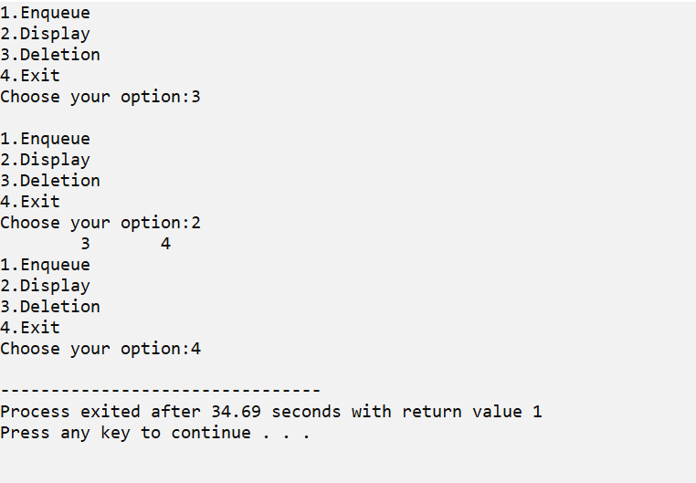

**Doubly Linked List.**

**Date:**

**Program #39**

**Source Code:**

#include <stdio.h>

#include <stdlib.h>

struct node {

int data;

struct node *next;

struct node *prev;

};

typedef struct node dll;

dll *head = NULL;

void insert(int a) {

dll *t;

if(head == NULL) {

head = (dll *)malloc(sizeof(dll));

head->data = a;

head->next = NULL;

head->prev = NULL;

}

else {

for(t = head;t->next != NULL;t= t->next)

;

t->next = (dll *)malloc(sizeof(dll));

t->next->data = a;

t->next->next = NULL;

t->next->prev = t;

}

}

void delete(int a) {

dll *t;

if(head == NULL)

printf("D L L is empty");

else if(head->data == a) {

if(head->next == NULL)

head = NULL;

else {

head = head->next;

head->prev = NULL;

}

}

else {

for(t = head; t != NULL && t->data != a;t = t->next)

;

if(t == NULL)

printf("Element Not Found");

else if(t->next == NULL)

t->prev->next = NULL;

else {

t->next->prev= t->prev;

t->prev->next = t->next;

}

}

}

void disp() {

dll *t;

for(t = head;t != NULL;t= t->next ) {

printf("%d\t",t->data);

}

}

int main()

{

int ch,e,n;

printf("\n DOUBLY LINKED LIST\n-------------------\n");

do{

printf("\n1.Insertion\n2.Deletion\n3.Display\n4.exit\n choose your option:");

scanf("%d",&ch);

switch(ch){

case 1:printf("\n enter element:");

scanf("%d",&e);

insert(e);

break;

case 2: printf("\n Enter element to be deleted:");

scanf("%d",&n);

delete(n);

break;

case 3:disp();

break;

case 4:exit(1);

break;

}

}while(1);

return 0;

}

**Output:**

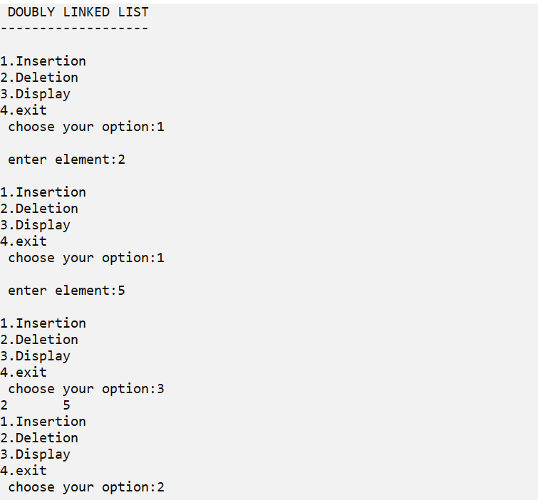

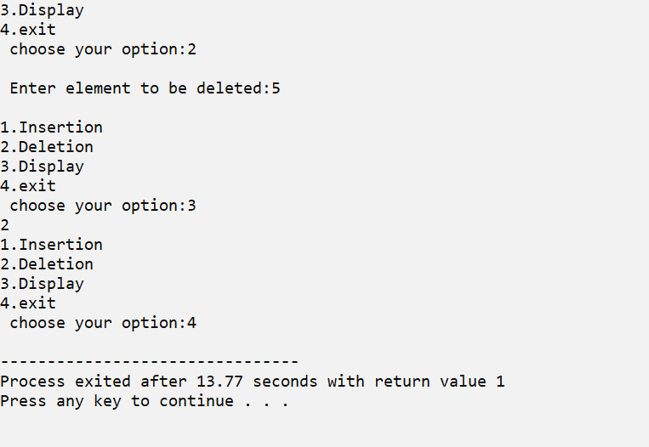

**Circular Doubly Linked List.**

**Date:**

**Program #40**

**Source Code:**

#include <stdio.h>

#include<stdlib.h>

struct node {

char data[100];

struct node *next,*prev;

};

typedef struct node cdll;

cdll * head = NULL;

void insert(char e[]) {

cdll *t;

if(head == NULL) {

head = (cdll *)malloc(sizeof(cdll));

strcpy(head->data, e);

head->next = head;

head->prev = head;

}

else {

for(t = head;t->next != head;t = t->next);

t->next = (cdll*)malloc(sizeof(cdll));

strcpy(t->next->data, e);

t->next->next = head;

t->next->prev = t;

head->prev = t->next;

}

}

void disp() {

cdll *t;

if(head == NULL) {

printf("Empty Linked List");

}

else {

t = head;

do {

puts(t->data);

t = t->next;

} while(t!=head);

}

}

void delete(int e) {

cdll *t;

if(head == NULL) {

printf("Empty Linked list");

}

else if(head->data == e && head->next == head) {

head = NULL;

}

else if(head->data == e) {

head->prev->next = head->next;

head->next->prev = head->prev;

head = head->next;

}

else {

t = head->next;

while(t !=head && t->data != e) {

t = t->next;

}

if(t == head)

printf("Not found");

else {

t->next->prev = t->prev;

t->prev->next = t->next;

}

}

}

int main()

{

char e[100];

int ch;

printf("\nCIRCULAR DOUBLY LINKED LIST");

printf("\n---------------------------");

do{

printf("\n1.Insert\n2.Display\n3.Exit\nChoose your option:");

scanf("%d", &ch);

getchar();

switch(ch){

case 1: printf("\nEnter name:");

gets(e);

insert(e);

break;

case 2: disp();

break;

case 3:exit(1);

break;

}

}while(1);

return 0;

}

**Output:**

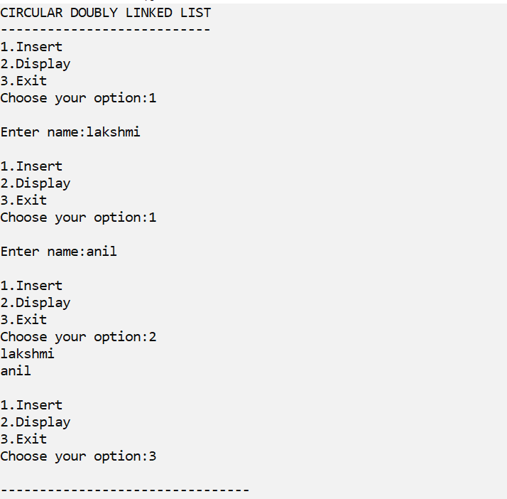

**Binary search tree insertion and display Traversal using inorder, preorder and postorder using recursion**

**.**

**Date:**

**Program #41**

**Source Code:**

#include <stdio.h>

#include<stdlib.h>

struct node {

int data;

struct node *left,*right;

};

typedef struct node tree;

tree*root = NULL;

void insert(int e) {

tree *t, *p;

if(root == NULL) {

root = (tree *)malloc(sizeof(tree));

root->data = e;

root->left = NULL;

root->right = NULL;

}

else {

t= root;

while(t != NULL) {

p=t;

if(t->data == e){

printf("Duplicate Key");

return;

}

else if(t->data > e) {

t = t->left;

}

else {

t = t->right;

}

}

if(p->data > e){

p->left = (tree *)malloc(sizeof(tree));

p->left->data = e;

p->left->left = NULL;

p->left->right = NULL;

}

else {

p->right = (tree *)malloc(sizeof(tree));

p->right->data = e;

p->right->left = NULL;

p->right->right = NULL;

}

}

}

void inorder(tree *r) {

if(r == NULL)

return;

inorder(r->left);

printf("%d\t",r->data);

inorder(r->right);

}

void preorder(tree *r) {

if(r == NULL)

return;

printf("%d\t",r->data);

preorder(r->left);

preorder(r->right);

}

void postorder(tree *r) {

if(r == NULL)

return;

postorder(r->left);

postorder(r->right);

printf("%d\t",r->data);

}

int main()

{

int ch,e,ch1;

printf("\n BINARY SEARCH TREE\n--------------------");

do{

printf("\n1.Insertion\n2.Display\n3.Exit\nChoose your option:");

scanf("%d", &ch);

getchar();

switch(ch){

case 1: printf("\nEnter no:");

scanf("%d",&e);

insert(e);

break;

case 2: printf("\n1.Inorder\n2.Preorder\n3.Postorder\nEnter your choice:");

scanf("%d",&ch1);

switch(ch1){

case 1:printf("\ninorder:");

inorder(root);

break;

case 2:printf("\npreorder:");

preorder(root);

break;

case 3:printf("\npostorder:");

postorder(root);

break;

}

break;

case 3:exit(1);

break;

}

}while(1);

return 0;

}

**Output:**

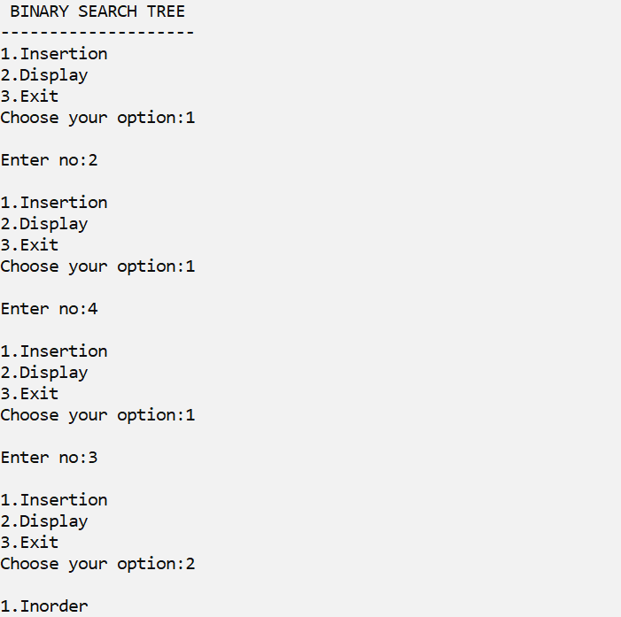

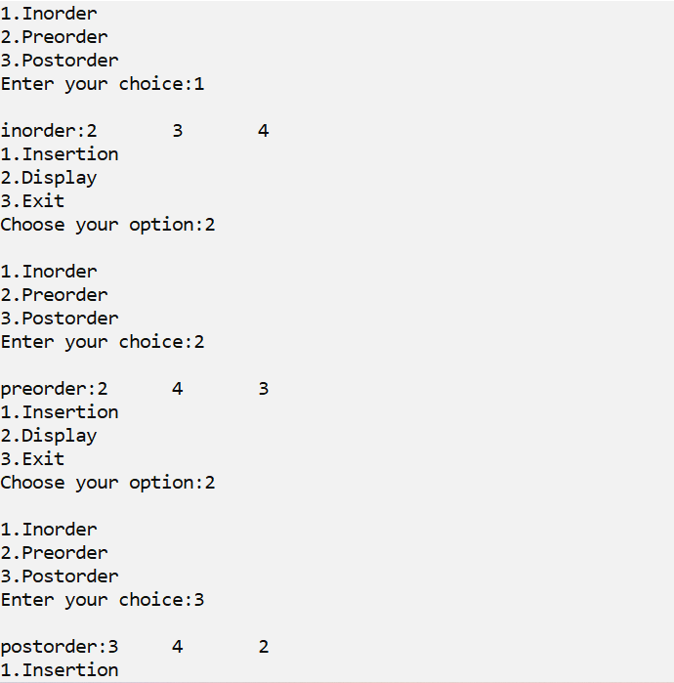



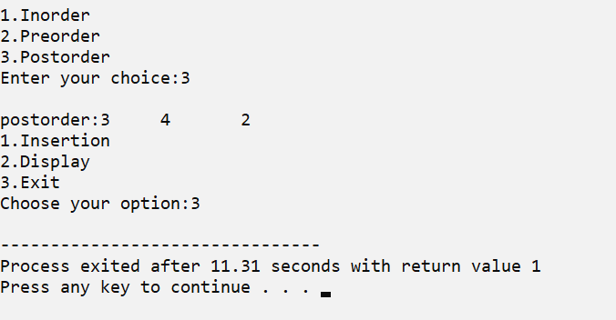

**Binary search tree insertion and display in-order without using recursion.**

**.**

**.**

**Date:**

**Program #42**

**Source Code:**

#include <stdio.h>

struct node {

int data;

struct node *left,*right;

};

typedef struct node tree;

struct stack {

tree *ptr;

struct stack *next;

};

typedef struct stack stack;

tree *root = NULL;

stack *top = NULL;

void push(tree *t) {

stack *temp = (stack *)malloc(sizeof(stack));//allocate new node

temp->ptr = t;

temp->next = top;

top = temp;

}

tree *pop(){

tree *t = NULL;

if(top != NULL) {

t = top->ptr;

top = top->next;

}

return t;

}

void inorderwor(tree *r) {

tree *t;

for(t = r;t != NULL;t= t->left) {

push(t);

}

t = pop();

while(t != NULL) {

printf("%d\t",t->data);

if(t->right != NULL) {

for(t = t->right;t != NULL;t= t->left) {

push(t);

}

}

t = pop();

}

}

void insert(int e) {

tree *p, *x;

if(root == NULL){

root = (tree*)malloc(sizeof(tree));

root->data = e;

root->left = NULL;

root->right = NULL;

}

else {

x = root;

while(x != NULL) {

p = x;

if(e < x->data) {

x = x->left;

}

else if(e > x->data){

x = x->right;

}

}

if(e < p->data) {

p->left = (tree*)malloc(sizeof(tree));

p->left->data = e;

p->left->left = NULL;

p->left->right = NULL;

}

else if(e > p->data){

p->right = (tree*)malloc(sizeof(tree));

p->right->data = e;

p->right->left = NULL;

p->right->right = NULL;

}

}

}

int main() {

int ch,e,ch1;

printf("\n BINARY SEARCH TREE\n--------------------");

do{

printf("\n1.Insertion\n2.Display\n3.Exit\nChoose your option:");

scanf("%d", &ch);

switch(ch){

case 1: printf("\nEnter no:");

scanf("%d",&e);

insert(e);

break;

case 2: inorderwor(root);

break;

case 3:exit(1);

break;

}

}while(1);

return 0;

}

**Output:**

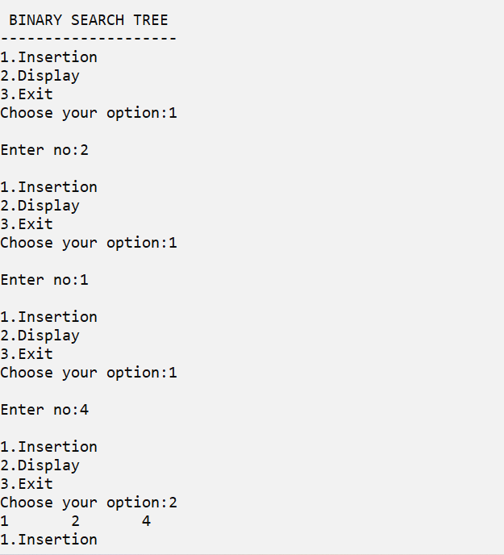

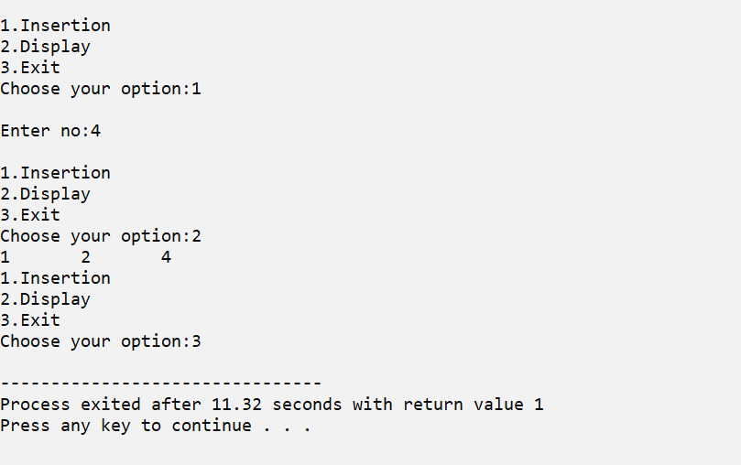

**Binary search tree insertion and display pre-order without using recursion.**

**.**

**.**

**Date:**

**Program #43**

**Source Code:**

#include <stdio.h>

struct node {

int data;

struct node *left,*right;

};

typedef struct node tree;

struct stack {

tree *ptr;

struct stack *next;

};

typedef struct stack stack;

tree *root = NULL;

stack *top = NULL;

void push(tree *t) {

stack *temp = (stack *)malloc(sizeof(stack));//allocate new node

temp->ptr = t; //copy data item

temp->next = top; // make the next as top

top = temp; // assign the new node address to top

}

tree *pop(){

tree *t = NULL;

if(top != NULL) {

t = top->ptr;

top = top->next;

}

return t;

}

void preorderwor(tree *r) {

tree *t;

for(t = r;t != NULL;t= t->left) {

printf("%d\t",t->data);

push(t);

}

t = pop();

while(t != NULL) {

if(t->right != NULL) {

for(t = t->right;t != NULL;t= t->left) {

printf("%d\t",t->data);

push(t);

}

}

t = pop();

}

}

void insert(int e) {

tree *p, *x;

if(root == NULL){

root = (tree*)malloc(sizeof(tree));

root->data = e;

root->left = NULL;

root->right = NULL;

}

else {

x = root;

while(x != NULL) {

p = x;

if(e < x->data) {

x = x->left;

}

else if(e > x->data){

x = x->right;

}

}

if(e < p->data) {

p->left = (tree*)malloc(sizeof(tree));

p->left->data = e;

p->left->left = NULL;

p->left->right = NULL;

}

else if(e > p->data){

p->right = (tree*)malloc(sizeof(tree));

p->right->data = e;

p->right->left = NULL;

p->right->right = NULL;

}

}

}

void main()

{

int ch,e,ch1;

printf("\n BINARY SEARCH TREE\n--------------------");

do{

printf("\n1.Insertion\n2.Display\n3.Exit\nChoose your option:");

scanf("%d", &ch);

switch(ch){

case 1: printf("\nEnter no:");

scanf("%d",&e);

insert(e);

break;

case 2: preorderwor(root);

break;

case 3:exit(1);

break;

}

}while(1);

}

**Output:**

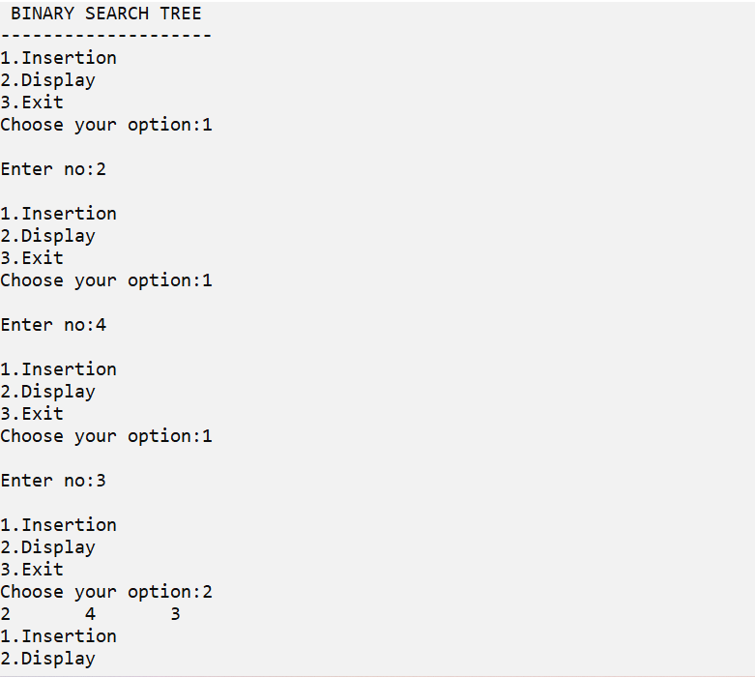

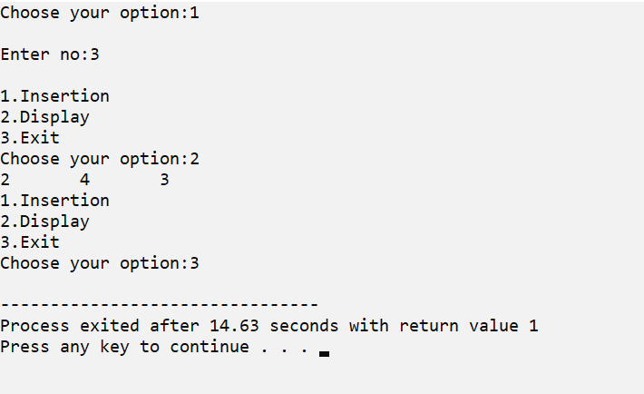

**Binary search tree insertion and display post-order without using recursion.**

**.**

**.**

**Date:**

**Program #44**

**Source Code:**

#include<stdio.h>

#include<stdlib.h>

#define MAX 50

struct node

{

struct node *lchild;

int info;

struct node *rchild;

};

struct node *insert_nrec(struct node *root, int ikey );

void nrec_post(struct node *root);

void display(struct node *ptr,int level);

struct node *queue[MAX];

int front=-1,rear=-1;

void insert_queue(struct node *item);

struct node *del_queue();

int queue_empty();

struct node *stack[MAX];

int top=-1;

void push_stack(struct node *item);

struct node *pop_stack();

int stack_empty();

int main( )

{

struct node *root=NULL, *ptr;

int choice,k;

printf("\n BINARY SEARCH TREE\n--------------------");

do

{

printf("\n");

printf("1.Insert\n2.Display\n3.Quit\n");

printf("\nEnter your choice : ");

scanf("%d",&choice);

switch(choice)

{

case 1:

printf("\nEnter value : ");

scanf("%d",&k);

root = insert_nrec(root, k);

break;

case 2:

nrec_post(root);

break;

break;

case 3:

exit(1);

default:

printf("\nWrong choice\n");

}

}while(1);

return 0;

}

struct node *insert_nrec(struct node *root, int ikey)

{

struct node *tmp,*par,*ptr;

ptr = root;

par = NULL;

while( ptr!=NULL)

{

par = ptr;

if(ikey < ptr->info)

ptr = ptr->lchild;

else if( ikey > ptr->info )

ptr = ptr->rchild;

else

{

printf("\nDuplicate key");

return root;

}

}

tmp=(struct node *)malloc(sizeof(struct node));

tmp->info=ikey;

tmp->lchild=NULL;

tmp->rchild=NULL;

if(par==NULL)

root=tmp;

else if( ikey < par->info )

par->lchild=tmp;

else

par->rchild=tmp;

return root;

}/*End of insert_nrec( )*/

void nrec_post(struct node *root)

{

struct node *ptr = root;

struct node *q;

if( ptr==NULL )

{

printf("Tree is empty\n");

return;

}

q = root;

while(1)

{

while(ptr->lchild!=NULL)

{

push_stack(ptr);

ptr=ptr->lchild;

}

while( ptr->rchild==NULL || ptr->rchild==q )

{

printf("%d ",ptr->info);

q = ptr;

if( stack_empty() )

return;

ptr = pop_stack();

}

push_stack(ptr);

ptr = ptr->rchild;

}

printf("\n");

}/*End of nrec_post( )*/

/*Functions for implementation of queue*/

void insert_queue(struct node *item)

{

if(rear==MAX-1)

{

printf("Queue Overflow\n");

return;

}

if(front==-1) /*If queue is initially empty*/

front=0;

rear=rear+1;

queue[rear]=item ;

}/*End of insert()*/

struct node *del_queue()

{

struct node *item;

if(front==-1 || front==rear+1)

{

printf("Queue Underflow\n");

return 0;

}

item=queue[front];

front=front+1;

return item;

}/*End of del_queue()*/

int queue_empty()

{

if(front==-1 || front==rear+1)

return 1;

else

return 0;

}

void push_stack(struct node *item)

{

if(top==(MAX-1))

{

printf("Stack Overflow\n");

return;

}

top=top+1;

stack[top]=item;

}/*End of push_stack()*/

struct node *pop_stack()

{

struct node *item;

if(top==-1)

{

printf("Stack Underflow....\n");

exit(1);

}

item=stack[top];

top=top-1;

return item;

}

int stack_empty()

{

if(top==-1)

return 1;

else

return 0;

}

**Output:**

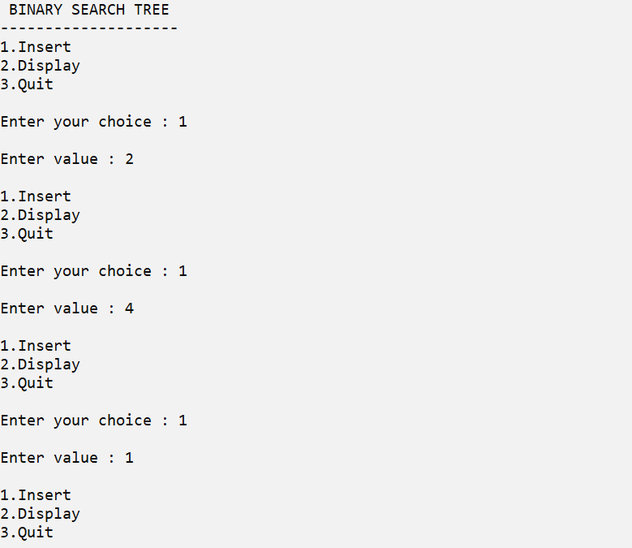

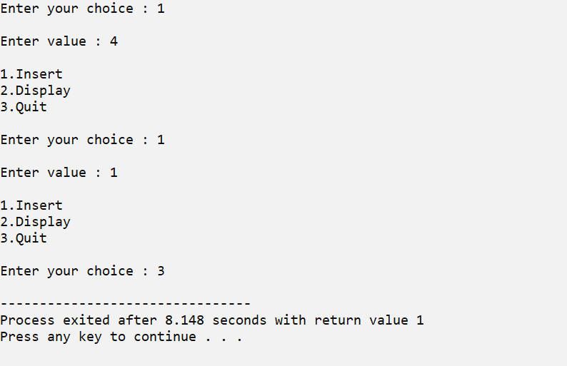

**Binary search tree insertion using names and display the names in ascending order using inorder traversal.**

**.**

**Date:**

**Program #45**

**Source Code:**

#include<stdio.h>

#include<string.h>

#include<stdlib.h>

#include<process.h>

struct dictionary{

char name[20];

struct dictionary *left,*right;

};

typedef struct dictionary dict;

dict *root=NULL;

int check(char a[],char b[]){

int i,j,c;

for(i=0,j=0 ; a[i]!='\0'&&b[j]!='\0' ; i++,j++){

if(a[i]>b[j]){

c=1;

break;

}

else if(b[j]>a[i]){

c=-1;

break;

}

else

c=0;

}

if(c==1)

return 1;

else if(c==-1)

return -1;

else

return 0;

}

void insert(dict *temp){

int flag=0;

dict *ptr,*p;

ptr=root;

if(root==NULL)

root=temp;

else{

while(ptr!=NULL ){

if(check(temp->name,ptr->name)>0){

p=ptr;

ptr=ptr->right;

}

else if(check(temp->name,ptr->name)<0)

{

p=ptr;

ptr=ptr->left;

}

else if(check(temp->name,ptr->name)==0){

flag=1;

printf("\n\nName exists!!!!");

break;

}

}

if(flag==0 && ptr==NULL){

if(check(p->name,temp->name)==1)

p->left=temp;

else if(check(p->name,temp->name)==-1)

p->right=temp;

}

}

}

void disp(dict *root){

if(root!=NULL){

disp(root->left);

printf("%s\t",root->name);

disp(root->right);

}

}

void main(){

dict *t;

int ch;

char w1[20];

printf("\nBINARY SEARCH TREE USING STRING\n--------------------------------------\n");

do{

printf("\n1.Insert\n2.Display\n3.Exit\nEnter your choice:");

scanf("%d",&ch);

switch(ch){

case 1:t=(dict*)malloc(sizeof(dict));

t->left=NULL;

t->right=NULL;

printf("\n Enter name:");

scanf("%s",t->name);

insert(t);

break;

case 2: printf("\nNames:");

disp(root);

printf("\n");

break;

case 3:exit(1);

break;

}

}while(1);

}

**Output:**

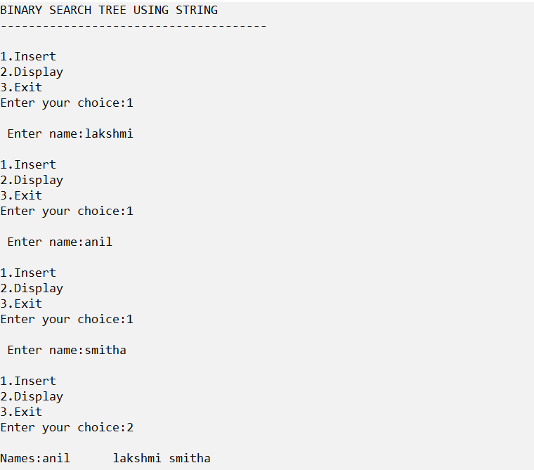

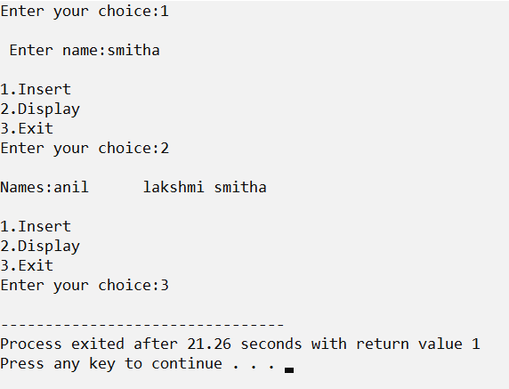

**Demonstrate the data structure of adjacent matrix using arrays.**

**.**

**.**

**.**

**Date:**

**Program #46**

**Source Code:**

#include <stdio.h>

#define V 4

// Initialize the matrix to zero

void init(int arr[][V]) {

int i, j;

for (i = 0; i < V; i++)

for (j = 0; j < V; j++)

arr[i][j] = 0;

}

void addEdge(int arr[][V], int i, int j) {

arr[i][j] = 1;

arr[j][i] = 1;

}

void printAdjMatrix(int arr[][V]) {

int i, j;

for (i = 0; i < V; i++) {

printf("%d: ", i);

for (j = 0; j < V; j++) {

printf("%d ", arr[i][j]);

}

printf("\n");

}

}

int main() {

int adjMatrix[V][V];

init(adjMatrix);

addEdge(adjMatrix, 0, 1);

addEdge(adjMatrix, 0, 2);

addEdge(adjMatrix, 1, 2);

addEdge(adjMatrix, 2, 0);

addEdge(adjMatrix, 2, 3);

printf("\n Adjancency Matrix\n-------------------\n");

printAdjMatrix(adjMatrix);

return 0;

}

**Output:**

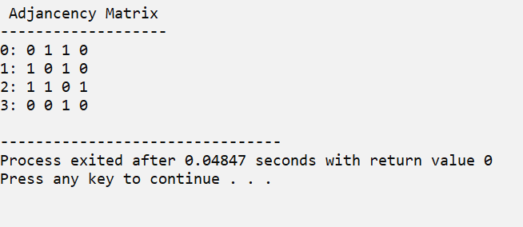

**Demonstrate the data structure of adjacent matrix  using linked lists.**

**.**

**.**

**Date:**

**Program #47**

**Source Code:**

#include <stdio.h>

#include <stdlib.h>

struct node {

int vertex;

struct node* next;

};

struct node* createNode(int);

struct Graph {

int numVertices;

struct node** adjLists;

};

struct node* createNode(int v) {

struct node* newNode = malloc(sizeof(struct node));

newNode->vertex = v;

newNode->next = NULL;

return newNode;

}

struct Graph* createAGraph(int vertices) {

struct Graph* graph = malloc(sizeof(struct Graph));

graph->numVertices = vertices;

graph->adjLists = malloc(vertices * sizeof(struct node*));

int i;

for (i = 0; i < vertices; i++)

graph->adjLists[i] = NULL;

return graph;

}

void addEdge(struct Graph* graph, int s, int d) {

struct node* newNode = createNode(d);

newNode->next = graph->adjLists[s];

graph->adjLists[s] = newNode;

newNode = createNode(s);

newNode->next = graph->adjLists[d];

graph->adjLists[d] = newNode;

}

void printGraph(struct Graph* graph) {

int v;

for (v = 0; v < graph->numVertices; v++) {

struct node* temp = graph->adjLists[v];

printf("\n Vertex %d\n: ", v);

while (temp) {

printf("%d -> ", temp->vertex);

temp = temp->next;

}

printf("\n");

}

}

int main() {

struct Graph* graph = createAGraph(4);

addEdge(graph, 0, 1);

addEdge(graph, 0, 2);

addEdge(graph, 0, 3);

addEdge(graph, 1, 2);

printf("\n Adjancency List\n-------------------\n");

printGraph(graph);

return 0;

}

**Output:**

